Project Specification Document

EIS AVEx Version

Jacob Dimoff, Nathan L’Abbe, Liam Morton, Michele Roosje, Khushpreet Sing, Noah Taylor

March 21, 2024

Project Design Specifications 4

Executive Summary. 4

System Request 4

Document Conventions 4

Proposed Solution - Scope 4

Outside Scope 4

Stakeholders 5

End Users 5

Components (User Class and Characteristics) 5

Development 6

Value 6

Team 6

System Components. 7

Office View 7

Web Application 8

Database 9

Livestock Entity Relationship Diagram 9

Server 9

Context 0 Diagram 9

DFD 10

System Environment. 10

Operation Constraints 10

Security 11

Operating Environment 11

ASSUMPTION DEPENDENCIES 11

External Interface Requirements 12

Hardware Interfaces 12

Software interfaces 12

Communications interface 12

Implementation Requirements. 13

Startup Processing 13

Initial Data Entry 14

User Training requirements 14

Software Test Plans 14

Introduction 14

Testing Environment 14

Software 14

Test Reporting 14

Summary 15

Time and Cost Estimates. 15

Schedule 15

Milestones 15

Cost Estimates 15

Staff Requirements 15

Appendix. 16

Appendix A. Risk Assessment 16

Appendix B. Gantt Chart 17

Appendix C. Pert Chart 17

Appendix D. Project Charter 18

Appendix E. Team Charter 19

Appendix E. Jira (Work Breakdown) 23

Appendix F-1 Home Page 33

Appendix F-2 Entry Contact Page 34

Appendix F-3. Entry Form Selection Mockup 35

Appendix F-4. Non-Livestock Mockup 36

Appendix F-5. Light Horse Entry Form Mockup 37

Appendix F-6. Horse Pulls Entry Form Mockup 38

Appendix F-7. Oxen Pulls Entry Form Mockup 39

Appendix F-8. Mini/Pleasure Driving Entry Form Mockup 40

Appendix F-9. Haflinger Entry Form Mockup 41

Appendix F-10. Beef Entry Form Mockup 42

Appendix F-11.Submission Confirmation (Entry) Mockup 43

Appendix F-12. Vendor Form Mockup 44

Appendix F-13. Sponsor Form Mockup 45

Appendix F-14 Parade Form Mockup 46

Appendix F-15. Submission Confirmation (Other) Mockup 47

Appendix F-16. Office Login Mockup 47

Appendix F-17. Office Home Mockup 48

Appendix F-18. Office – Create Schedule Mockup 49

Appendix F-19.Office - Edit Form Mockup 50

Appendix F-20. Sponsor Contribution Mockup 51

Appendix F-21. Sponsor Search Mockup 51

Appendix F-22. Category Total Sponsorship Mockup 52

Appendix F-23. Entry Lookup by Name Mockup 52

Appendix F-24. Entry Lookup by ID Mockup 53

Appendix F-25. Invoice Home (Lookup) Mockup 53

Appendix F-26. Invoice - Create Mockup 54

Appendix F-27. Invoice – Invoice – Confirm / Print 55

Appendix F-28. Invoice – Add Person Mockup 55

Appendix F-29. Invoice – Record Payment Mockup 56

Appendix F-30. Invoice – Add Item Mockup 56

# Project Design Specifications

## Executive Summary.

### System Request

Design a program to track sponsors, vendors, event entries for an agricultural exhibition. Produce the required reports, invoices, and documentation from the database for the event.

### Document Conventions

EIS Event Information System

Exhibition Annapolis Valley Exhibition

### Proposed Solution - Scope

This document includes details about an information system that will:

* track sponsors, vendors, and entries.
* Summarize the data into an invoice to be sent to the user.
* Track sponsors including what events they are sponsoring, how much they sponsor, and what star rating they receive for their sponsorship.
* Track vendors including what type of vendor they are, what size space they will have, and where they will be located.
* Track entries including who is in each event, each category they enter in the event, and when they will be showing.
  + There are two types of entries livestock and non-livestock.
* All the data will be stored in a MySQL database.
* Invoices will be automatically created when an entry is submitted. The invoice will be emailed to the entrant and an office email.
* Administration section will allow changes to the forms. This will have a login.
* Office page will allow edits to submitted forms as well as creating various documents from the stored information. This will have a login.
* Invoice page to create additional invoices and make changes to previously created invoices. This will be accessed from the Office section.
* Allow entrants to enter their contact information once and then enter as many categories as they want without entering the contact information again.

### Outside Scope

These are additional things that can be added later.

* Track the judging results for non-livestock with a judging web app.
* Track main ring judging results.
* Give each exhibitor a number that stays with them from year to year.
* Allow entrants to edit their forms after they have been submitted.
* Redneck Rodeo and Modified Truck and Tractor forms, children's contest forms, mobile concessions form, and winter storage form.
* Hosting the program.

### Stakeholders

The Exhibition Board of Directors. All related committee members. Staff of the Exhibition.

### End Users

The Exhibition staff, entrants, sponsors, and vendors of the Exhibition.

### Components (User Class and Characteristics)

There will be three types of users, with varying levels of permissions. The first user will be the Administrator which will have administration access. They will edit and update the various forms as well as create an excel backup of the entire database each year before resetting the database by deleting the content from specific tables. The second type of user will be office staff, they will be able to edit the submitted forms and print required documents by retrieving information from the database using backend queries. The third and final type of user will be the customers, henceforth called website users, filling the forms through the website which will be entered into the database as Website Account.

The website users will be able to fill out the following forms:

* livestock entry forms
* non-livestock entry forms
* parade entry forms.
* vendor forms
* sponsor forms

The office users will be able to do what the outside users can as well as:

* edit submitted forms
* print submitted forms
* retrieve information for the various documents and reports required
* create invoices
* edit invoices
* print and email invoices

The administration user should have access to the other functions as well as:

* create, edit and view, the forms
* remove data from the database each year to collect the new entry information

### Development

The project will be created in the Laravel framework using PHP. Multiple views will be created. At least one view for each entry form required, multiple invoice views, administration views, and office staff views.

### Value

Last year the exhibition used an Access database and online forms. This was a change as all the entries had been submitted on paper before this and it took a lot of time to process them and create the required documents for exhibition week. The Access database and online forms were faster than the paper submissions, but they had no user interface and required IT knowledge to create, edit, and use for the office staff. The EIS system will have a user-friendly interface so the office staff will be able to use the program without much IT knowledge. This will save many hours of work as opposed to collecting the submissions on paper. It will also be much easier to create the required documents and reports for exhibition week.

## Team

* **Michele Roosje** - Project Manager and Lead on livestock entry forms - Help create the contact page that will be used for all entry forms, create the index livestock page that will be used for all livestock entry forms, and the individual views for each livestock category as time allows. Create the connected controllers and routes as well as CSS. Manage the project.
* **Jacob Dimoff** – Project Coordinator and Database Creation – Help manage Jira and help with planning and documentation, create the entry database with all the required relationships. Create diagrams and provide the schema to be included in the project. Create queries to produce the required deliverables.
* **Noah Taylor** – Lead Non-livestock entry forms, Create the navigation bar that will be used for all entry forms. Create the non-livestock form that will be used for all non-livestock entries. Create the connected controllers and routes as well as CSS. Create some of the livestock forms. If time allows, create a web-based judging app that will send the results of the non-livestock judging to the database.
* **Khushpreet Singh** – Lead other forms which include sponsor, vendor, and parade. Create the connected controllers and routes as well as CSS. create some livestock forms.
* **Nathan L’Abbe** –Lead Security and Testing, Database queries – security and testing. Work with Jacob to create queries to produce the required documents and reports for the office staff. Create admin and office logins and pages.
* **Liam Morton** – Lead Programmer and Lead Invoice System – Help anyone who has trouble with their code as well as creating the invoicing system which will include a form to create invoices and invoices auto generated and emailed from entry form submissions. Liam has more experience in PHP than the rest of us as he has done a work term working with it.

## System Components.

Below is a sample of a page that will be included in the system. You can find of the pages in Appendix.F

### Office View

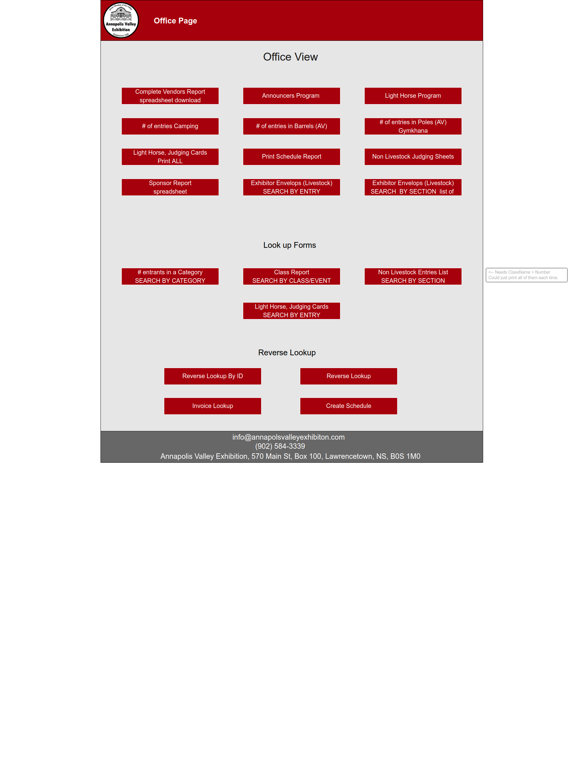

### Web Application

The project will be created in the Laravel framework using PHP. The following pages will be created.

* Home – will have access to office and admin logins, entry forms, sponsor form, parade form, vendor form
* Contact – entries contact information
* Confirm Form Entry – conformation page for entries
* Confirm Form Other – confirmation for parade, sponsor, and vendor
* Sponsor form
* Vendor form
* Parade form
* Non-livestock form
  + One form containing options to enter Fruit & Vegetable, Creative Crafts, Rug Hooking, Art, Photography, Flowers, Cooking, Woodworking
* Livestock forms
  + Beef
  + Dairy
  + Light Horse
  + Mini/Pleasure Driving
  + Haflinger
  + Horse Pulls
  + Oxen Pulls
* Admin Login
* Office Login
* Office Home
  + Create Schedule
  + Edit Form
  + Entry Lookup by Name
  + Entry Lookup by ID
  + Sponsor Contribution
  + Sponsor Search
  + Category Sponsorship Total
* Invoice Lookup Main Page
  + Create Invoice
  + Confirm / Print Invoice
  + Add Person
  + Add Item
  + Payment

### Database

The information collected from the forms will be sent to a MySQL database. Designed to collect entry information and use predefined queries to produce the documents the exhibition requires for the announcer's booth, and the office staff as well as collect all the invoice information and produce invoices. Invoices will auto generate from the form submissions and be emailed to the entrant and an office email.



#### Non-Livestock Entity Relationship Diagram

#### Invoice System Entity Relationship Diagram

### Server

One server will be used to host the forms and the database.

### Context 0 Diagram

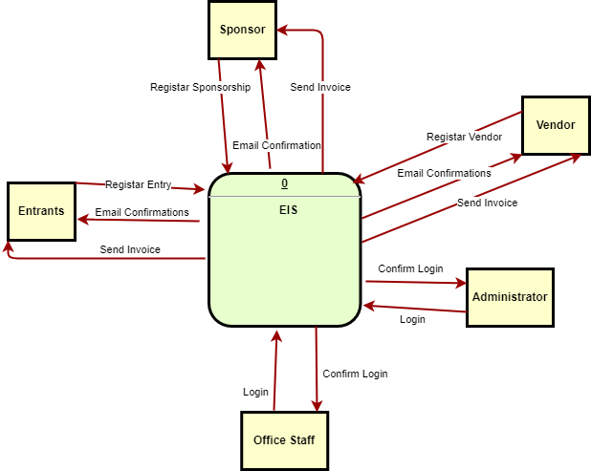

### DFD

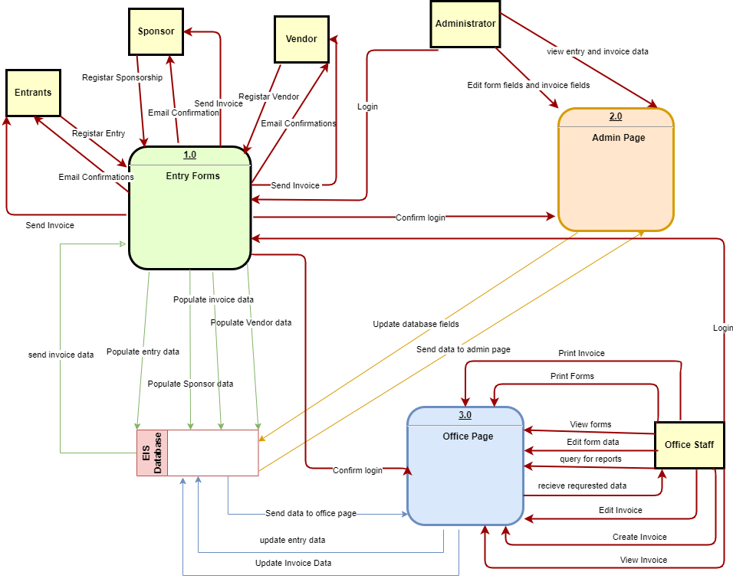

## System Environment.

### Operation Constraints

Foreseeable operation constraints include storage, CPU and RAM in the instance.

Storage could be an issue due to saving invoicing information for seven years, and after seven years it can be deleted.

The amount of RAM and CPU power determines the amount of traffic that can visit the website at once and how smooth and quick the Virtual Machine is (i.e. load times, bootup, etc..). This should not be an issue as we do not expect there to be enough traffic to bring down the site.

Security   
Security Tests to be ran against each form.

* SQL Injection
* Privilege Escalations

Ensure each form has minimal required permissions, along with ensuring communication is encrypted between the website user and the website server, with extra focus on ensuring passwords are not sent across in plaintext.

### Operating Environment

Prototype Environment

Local Computer at NSCC COGS room 115, which will host both the MySQL Database and the Website Server

Operating System: Windows Server 2022

Database: MySQL Database Hosted on Website Server.

Platform: Laravel 10 / MySQL

Languages Used: MySQL, HTML, CSS, PHP, Mail Server

Client/Server System

Cloud Environment

Two Virtual Machine hosted by a provider to be determined later, one to host the MySQL Database and another to host the Website Server

Operating System: Windows Server 2022

Database: MySQL Database Hosted on Website Server.

Platform: Laravel 10 / MySQL

Languages Used: MySQL, HTML, CSS, PHP, Mail Server

Client/Server System

### ASSUMPTION DEPENDENCIES

1. Laravel 10 will be able to be installed along the mail server and MySQL database running at the same time for the prototype to be possible.
2. The administrator will have some knowledge of MySQL to understand the ramifications of what they are doing when they modify or remove certain forms.
3. The system updates will be able to be ran by the service provider for the Virtual Machine when we move to the cloud version, and only ran when the forms are no longer available for that year’s exhibition.
4. Windows Server 2022 will not go down for updates while it is hosting the website forms for the public, and that the internet is still working.

### External Interface Requirements

• Frontend: Laravel 10, PHP 8.3

• Backend: MySQL 8.0

### Hardware Interfaces

• Windows Server 2022

• A browser that supports PHP, HTML, JavaScript, CSS.

### Software interfaces

Laravel, PHP:

We are using the most recent version of larval (this being version 10) as well as the required version of PHP for this version. Our reason for using the Laravel framework is to allow for more efficient code and security in our website forms. We also have experience with this framework.

Database:

We will use MySQL for storing our invoice and signup information. MySQL is a program that our group has used in the past and feel most commutable using.

### Communications interface

The website will support most web browsers. We will use electronic forms and menus that are specifically designed to be user friendly. There will be a sign-in for the invoice and an admin sign in to edit the forms and to add items in the invoice.

The website will be hosted on our own devices for testing and once completed the web forms and databases will be moved to a server provider server for public use.

Server:

The server provider that is yet to be decided by the exhibition committee will be used to host our frontend and backend. However, all options that are provided can do the following, allow for large influx of users, support MySQL, support PHP and PHP frameworks (such as Laravel), and server maintenance and support. Other info like CPUs, RAM and other hardware information will be determined once the provider is chosen.

Email Server:

The mailing server is yet to be determined however an email server is required for the Invoice and entry forms to be automatically sent. The Exhibition currently uses google for their email service.

## Implementation Requirements.

### Startup Processing

Starting February 10, 2024, we will be moving from the planning phase to the design phase of our project. March 12, 2024, we will be moving from the design phase of our project to the execution phase, everything that we currently have planned for will be put into motion. This includes, creating views, creating the database, and creating the invoice system.

**Project Initiation**:

* **Sponsors:** Annapolis Valley Exhibition Board of Directors. Establish communication to pitch project idea.
* **Stakeholders:** Committees, sponsors, vendors, entrants, office staff of the Exhibition are stakeholders.
* **Entries**: Establish entry process for exhibition, including entry forms, deadlines, and submission deadlines.

**Project Governance:**

* **Decision making processes**: The team will discuss ideas and work together to make decisions. The project manager has the authority to make final decisions on various aspects of the project.
* **Communication protocols**: The team will communicate through discord. They also have the option to communicate by email, phone, or on teams. Communication with stakeholders will be done primarily through email and occasionally by text or phone call.

**Resource Allocation:**

* **Divided work amongst team members**: Assign tasks and responsibilities to each team member based on their expertise and role within the project.
* **Procurement:** Resources or materials needed for the project are open-source software including Laravel, PHP, and MySQL. They will be downloaded from the internet. Once the system is in place the Exhibition will require a way to host it and an email server to send the confirmation emails and invoices.

**Risk Assessment:**

* **Potential Risks/Uncertainties:** Potential risks and uncertainties that could affect the project, are time constraints. We have a very ridged timeline to complete the project. SQL injection is our top security risk.
* **Strategies to mitigate/manage:** The timeline may be extended with work term placements for 3 members of the team.

**Development (WAMP):**

* Windows 10 and 11
* Apache
* MySQL
* PHP 8.3
* Laravel 10

### Initial Data Entry

All the classes and section names will have to be entered into the database by Jacob.

### User Training requirements

The team will provide instructions for each section of the system and a PDF manual of the basics. We will also be available during the first week to answer questions and help familiarize the Board with how the system works, and how to operate it. The program will be installed at the Exhibition on April 6th.

### Software Test Plans

#### Introduction

Purpose – The purpose of this plan is to make sure that the EIS Program will function without issue, that every lose end will be tied up, and solved and that no data leaks will occur.

Scope – This plan will cover the tests that will be done to ensure that the program functions without issue and that no data leaks will occur once launched.

#### Testing Environment

Hardware – Computer with internet connection at the exhibition office.

#### Software

* Web browser
* A screen capturing tool.
* A Security testing tool

#### Test Reporting

Test reports should be saved as a PDF document daily once done and checked properly.

#### Summary

The EIS Program will be thoroughly tested and debugged to ensure proper functionality. The team will test it first and then the Exhibition will get multiple people to test it.

## Time and Cost Estimates.

### Schedule

Please refer to Appendix A. Gnatt Chart for the original schedule. This chart displays the structure and scheduling for the entire project.

### Milestones

|  |  |  |
| --- | --- | --- |
| *Each task number includes all its child issues* | **Start Date** | **End Date** |
| Define Requirements/Information Gathering  EIS-65 | January 08 | March 22 |
| Planning & Design  EIS-69 | January 10 | March 11 |
| Project Specification Document  EIS-2 | January 10 | March 17 |
| Implementation  EIS-210 | March 12 | April 6 |
| Testing  EIS-10 | March 12 | April 12 |
| Deployment  EIS-11 | April 6 | April 6 |
| Operations and Maintenance  EIS-80 | April 6 | April 12 |
| IT Fair Presentation  EIS-196 | April 1 | April 5 |
| Closing  EIS-36 | April 12 | April 17 |

### Cost Estimates

The initial cost for this project will be free as everything to be implemented will be done using free software and the team creating it is volunteering their time. The Exhibition will need to pay for hosting and an email server. The team will track hours for approximate development cost estimate.

### Staff Requirements

The Exhibition staff will be able to use the program with little or no guidance after the initial training which will be provided when the project is deployed.

## Appendix.

### Appendix A. Risk Assessment

|  |  |
| --- | --- |
| **STRENGTHS** | **WEAKNESSES** |
| * **Efficiency Improvement**: streamline the process of tracking vendors and entries by replacing manual paper submissions and Access database entries * **User-Friendly Interface** * **Automated Invoicing**: With invoices being sent automatically, this reduces the administrative burden and insures timely processing. This improves accuracy and speeds up the invoicing process * **Data Management:** Utilizing MySQL queries can/will speed up documenting and reporting | * **Technical Dependencies**: Successful implementation relies on dependencies, such as compatibility of Laravel 10 and a mail server that may need to be implemented * **Resource Constraints**: Project lacks a defined budget, which could pose challenges for resource allocation and procurement * **Time Constraints**:There is a lot to do in a small window of time, there are also going to be things that go wrong, so we will have to account for that as well as project completion time * **Training Needs:**  There is a need for comprehensive admin training to ensure stakeholders or whoever is administrating the website, can ensure that all stakeholders can effectively use the system |
| **OPPORTUNITIES** | **THREATS** |
| * **Scalability:** can be scaled to accommodate additional features/functions based on feedback or future requirements * **Reporting Capabilities:** Enhance reporting capabilities with MySQL * **Cloud Migration:** Although we will be running our tests on a local environment, there is an opportunity to fully migrate it to a cloud-based infrastructure, making it a solid option for long term sustainability | * **Security Risks:** Must address potential security with sensitive information, such as entrant details and financial data. Failure to implement security could result in data breaches, as well as damage reputation * **Technical Challenges:** The complexity of developing a web application using Laravel and PHP introduces the risk of technical challenges or coding errors * **Competitive Landscape:** There is a small risk of competition from alternative solutions or existing software |

### Appendix B. Gantt Chart

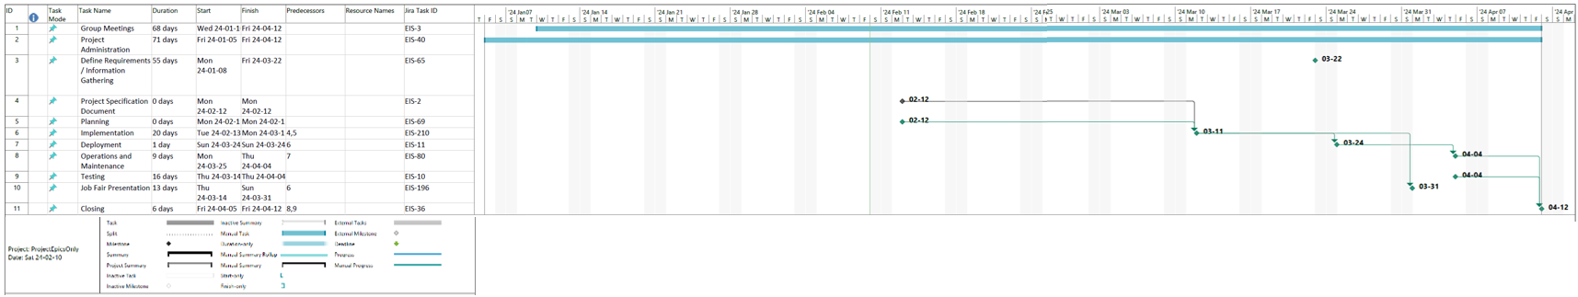

### Appendix C. Pert Chart

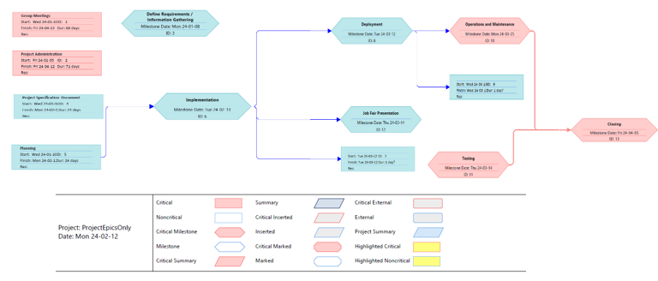

### Appendix D. Project Charter

**PROJECT CHARTER**

|  |  |  |  |
| --- | --- | --- | --- |
| PROJECT NAME | | PROJECT MANAGER | PROJECT SPONSOR |
| Capstone | | Michele Roosje | Annapolis Valley Exhibition |
| ESTIMATED COSTS | EXPECTED SAVINGS | EXPECTED START DATE | EXPECTED COMPLETION |
| $0 | $0 | 01/08/2024 | 04/12/2024 |

PROJECT OVERVIEW

|  |  |
| --- | --- |
| PROBLEM  OR ISSUE | The largest risk with this project is running out of time. We also must find an efficient way to share our code with each other. We must be careful that our individual work has a uniformity for the overall project.    The database must be set up to store all the information and we mush prevent SQL injection. We must try to make sure the staff cannot accidently delete or damage the database or forms. |
| PURPOSE  OF PROJECT | Design a program to track sponsors, vendors, and entries for the Annapolis Valley Exhibition. |
| BUSINESS  CASE | Expected costs for the project will include a way to host the program and the hours the team members spend working on the project, although there will be no charge for the hours. The expected benefits from the project include saving time and streamlining the registration process for events. |
| GOALS / METRICS | Develop a user-friendly system to replace manual data entry and document creation processes.   * Implement an online form system integrated with a MySQL database for efficient data management. |
| EXPECTED DELIVERABLES | * Livestock entry forms * Non-livestock entry forms * Sponsor form * Vendor form * Web-based invoicing system * MySQL databases |

PROJECT SCOPE

|  |  |
| --- | --- |
| WITHIN  SCOPE | This document includes details about an information system to track sponsors, vendors, and entries. This system will also allow the summarize the data into an invoice to be sent to the user. Tracking sponsors includes what events they are sponsoring, how much they sponsor, and what star rating they receive for their sponsorship. Tracking vendors includes what type of vendor they are, what size space they will have, and where they will be located. The entries include tracking who is in each event, each category they enter in the event, and when they will be showing. There are two types of entries livestock and non-livestock. All the data will be stored in a MySQL database. There will be invoices automatically created when an entry is submitted. The invoice will be emailed to the entrant and an office email. The invoice information will be stored in a separate MySQL database. The system will include an administration page to make changes to the forms, an office administration page to edit submitted forms as well as creating various documents from the stored information, and an invoice page to create additional invoices and make changes to previously created invoices. A judging web app will be created for Fruit and Vegetable if time allows. |
| OUTSIDE  OF SCOPE | These are additional things that can be added if time allows or later. Track the judging results for non-livestock. Track main ring judging results. Give each exhibitor a number that stays with them from year to year. Allow entrants to enter their contact information once and then enter as many different categories as they want without entering the contact information again. Allow entrants to edit their forms after they have been submitted. Redneck Rodeo and Modified Truck, Tractor forms, children's contest forms, mobile concessions form, and winter storage form. Hosting the program. |

### Appendix E. Team Charter

**Team Charter**

|  |  |  |  |
| --- | --- | --- | --- |
| Team Name | | | Team Leader |
| EIS Team | | | Michele Roosje |
| Project Name | | | Duration |
| Event Information System – AVEx Version | | | January 8, 2024, to April 12, 2024 |
| Background | * Design a program to track sponsors, vendors, and entries for an exhibition. * Stakeholders include the Board of Directors for the Annapolis Valley Exhibition as well as all the committees involved. * Our team has experience using Laravel to create forms and connecting them to a database. | | |
| Mission  And  Objectives | * A successful project would include our team creating the forms and the database(s). * The current system the exhibition has in place requires IT knowledge to use. They would have to return to paper entries and manually enter all the information in various spreadsheets without this program. | | |
| Roles  And  Responsibilities | | * **Michele Roosje** - Project Manager and Lead on livestock entry forms - Help create the index.blade.php that will be used for all entry forms, create the livestock.blade.php that will be used for all livestock entry forms, and the individual views for each livestock category as time allows. Create connected controllers and routes as well as CSS. Manage the project. * **Jacob Dimoff** – Project Coordinator and Database Creation – Help manage Jira and help with planning and documentation, create the entry database with all the required relationships. Create diagrams and provide the schema to be included in the project. Create queries to produce the required deliverables. * **Noah Taylor** – Lead Non-livestock entry forms, Help create the index.blade.php that will be used for all entry forms, create the nonLivestock.blade.php that will be used for all non-livestock entry forms, and the individual views for each non-livestock category as time allows. Create connected controllers and routes as well as CSS. Create a web-based judging app that will send the results of the non-livestock judging to the database if time allows. * **Khushpreet Singh** – Lead other forms which include sponsors, vendors, and parade. Help create the index.blade.php that will be used for all entry forms and the individual views for each form. Create connected controllers and routes as well as CSS. Help with creating livestock and non-livestock forms. * **Nathan L’Abbe** – Lead Security and Testing, Database Creation – security and testing, help Jacob with creating the entry database with all the required relationships. Create queries to produce the required deliverables. Create admin and office views. * **Liam Morton** – Lead Programmer and Lead Invoice System – Help anyone who has trouble with their code as well as creating the invoicing system which will include a form to create invoices, a database to store the information, and invoices auto generated and emailed from entry form submissions. | | |
| Team Operations | * New people enter the project by talking to the project manager. * Members leave the team if they do not attend meetings or don’t complete assigned work on time without a good reason. * When a team member has completed their initial part of the project, they will help create the multiple views required for the non-livestock and livestock forms and we will all help with testing. * The project manager will be available for questions or support. The lead programmer will help with programming related issues. The project coordinator will help organize the work breakdown and help with required diagrams. | | |

|  |  |
| --- | --- |
| Scope | An information system to track sponsors, vendors, and entries. This system will also allow the summarization of the data into an invoice to be sent to the user. Tracking sponsors includes what events they are sponsoring, how much they sponsor, and what star rating they receive for their sponsorship. Tracking vendors includes what type of vendor they are, what size space they will have, and where they will be located. The entries include tracking who is in each event, each category they enter in the event, and when they will be showing. There are two types of entries livestock and non-livestock. All the data will be stored in a MySQL database. There will be invoices automatically created when an entry is submitted. The invoice will be emailed to the entrant and an office email. The invoice information will be stored in the same MySQL database for the entry forms. The system will include an administration page to make changes to the forms, an office administration page to edit submitted forms as well as creating various documents from the stored information, and an invoice page to create additional invoices and make changes to previously created invoices. |
| Performance Assessment | * Progress and performance are measured by our progress on Jira, our submitted timesheets, our submitted meeting minutes, our documentation, our program, our IT fair display, and our reflections. * Our Capstone teacher Sharla will assess the team. |
| Activities  And  Milestones | Tasks   * Design and create web-based forms. * Design and create a database for exhibition entries and invoice information. * Design and create an inventory system including a database. * Create instructions and documentation. * Test every aspect of the project. * Deploy the system. * Train someone in using the system. * Fix problems with the system.   Milestones   * Define Requirements/Information Gathering * Planning * Project Specification Document * Implementation * Testing * Deployment * Operations and Maintenance * IT fair Presentation * Closing |

|  |  |
| --- | --- |
| Guide  To  Communications | * The team will communicate through Discord, email, phone, and/or text. * The team will meet a minimum of once a week. Mondays from 10:30 to 11:30 and/or 12:30 to 1:30 either in person or on Teams. * Status reports will be given verbally at each meeting. They will also be submitted to our Capstone teacher on the following dates: * Jan 19, Feb 9, Mar 1, Mar 29. |

**Team’s Dated Signatures**

|  |  |
| --- | --- |
| Michele Roosje | Date |
|  | February 10, 2024 |
| Jacob Dimoff | Date |
|  | February 12, 2024 |
| Noah Taylor | Date |
|  | February 12, 2024 |
| Khushpreet Singh | Date |
|  | February 12,2024 |
| Nathan L’Abbe | Date |
|  | February 12, 2024 |
| Liam Morton | Date |
|  | 2024-02-12 |

### Appendix F-1 Home Page

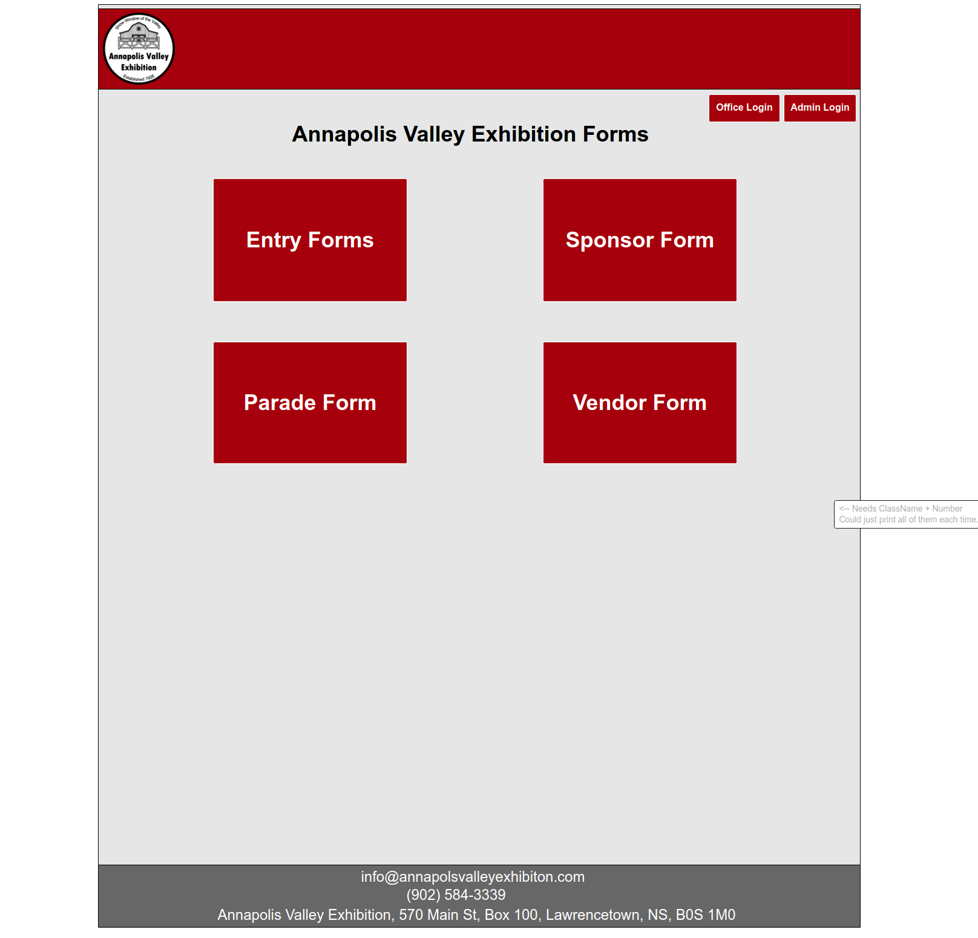

### Appendix F-2 Entry Contact Page

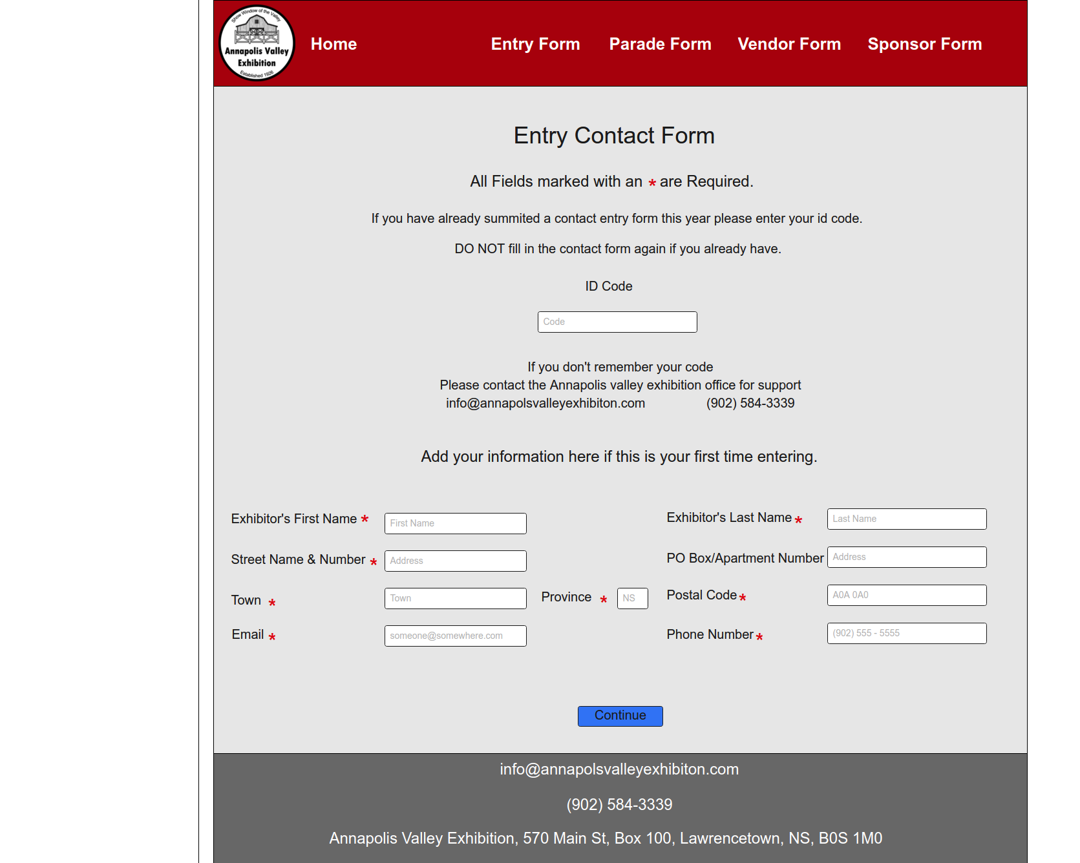

### Appendix F-3. Entry Form Selection Mockup

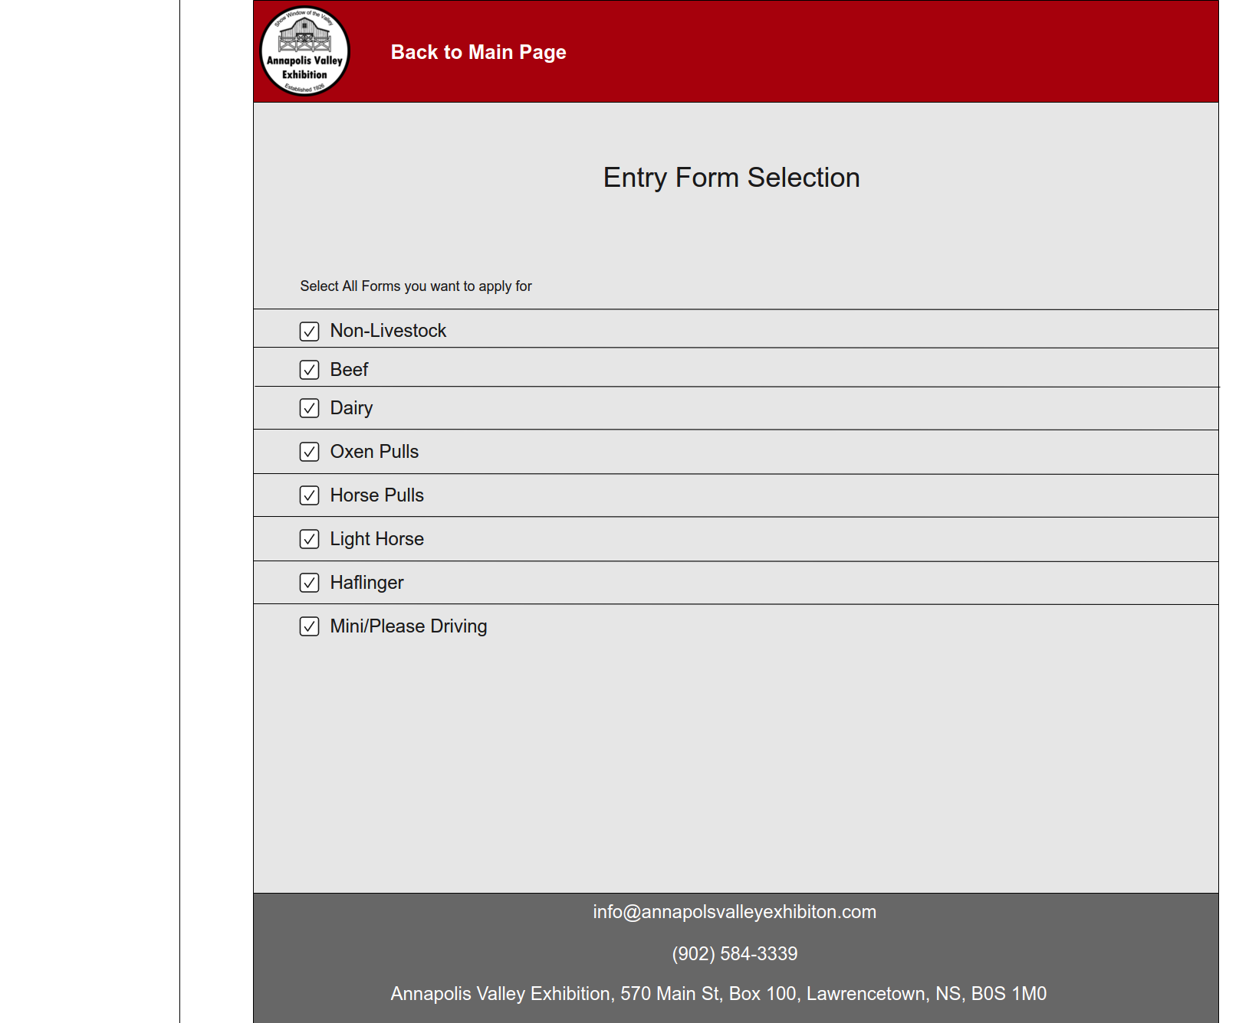

### Appendix F-4. Non-Livestock Mockup

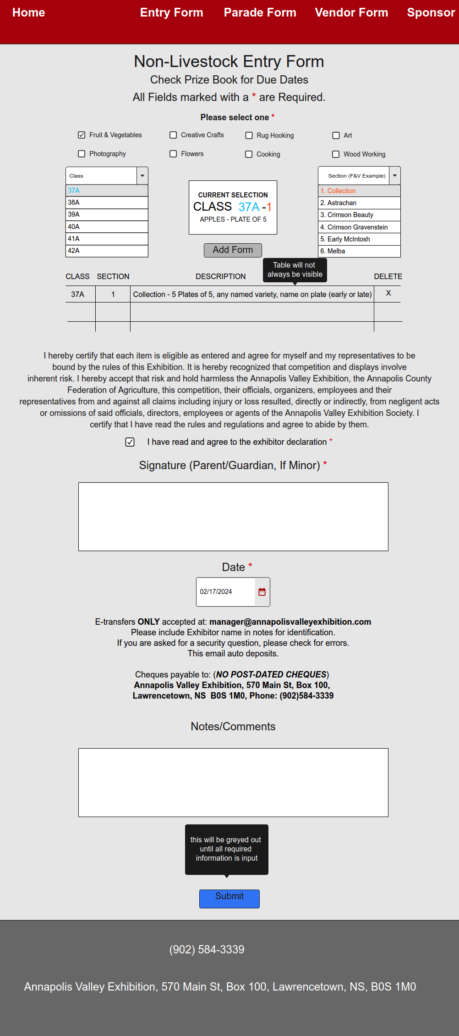

### Appendix F-5. Light Horse Entry Form Mockup

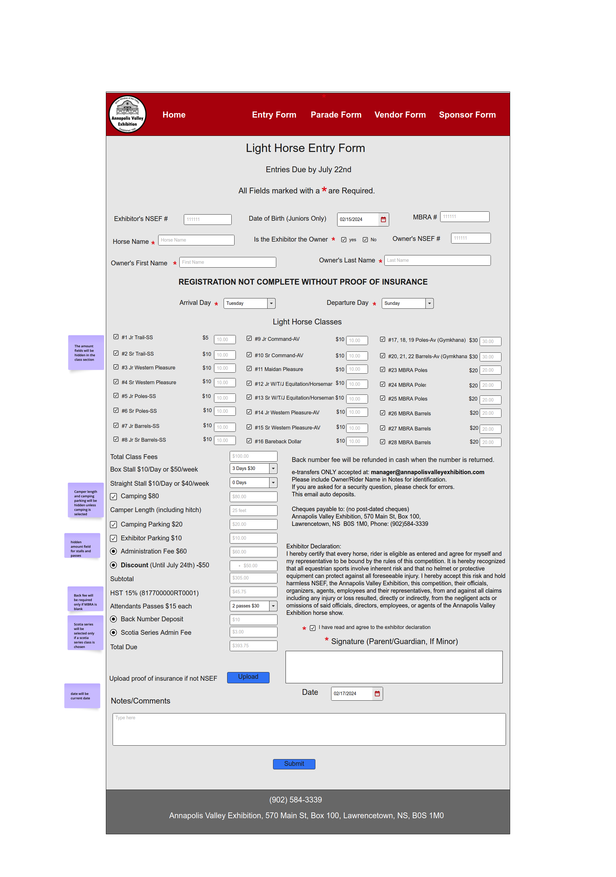

### Appendix F-6. Horse Pulls Entry Form Mockup

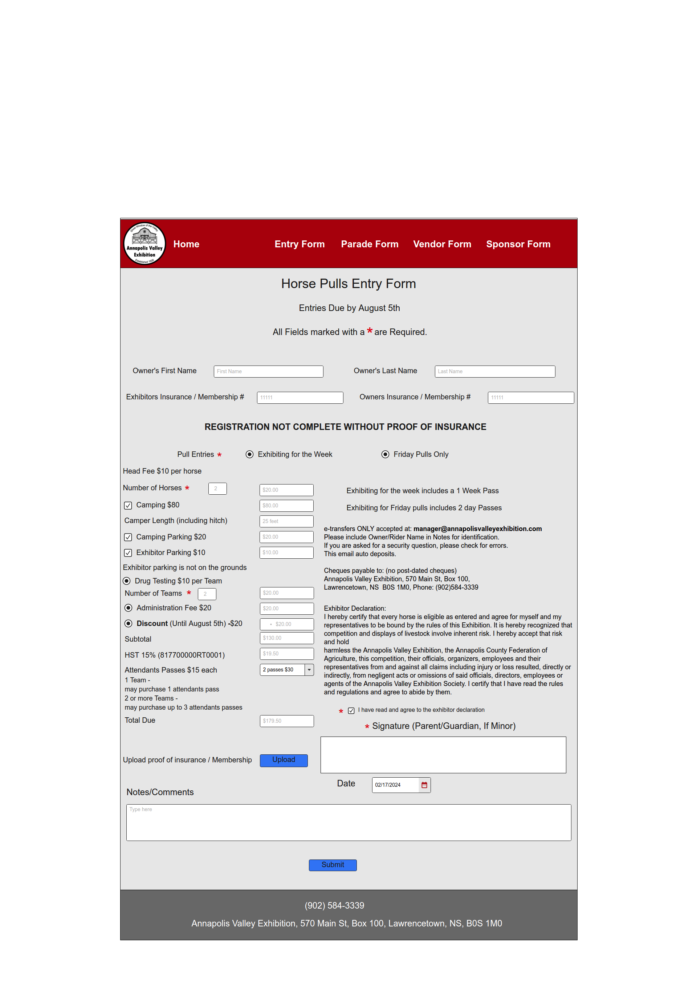

### Appendix F-7. Oxen Pulls Entry Form Mockup

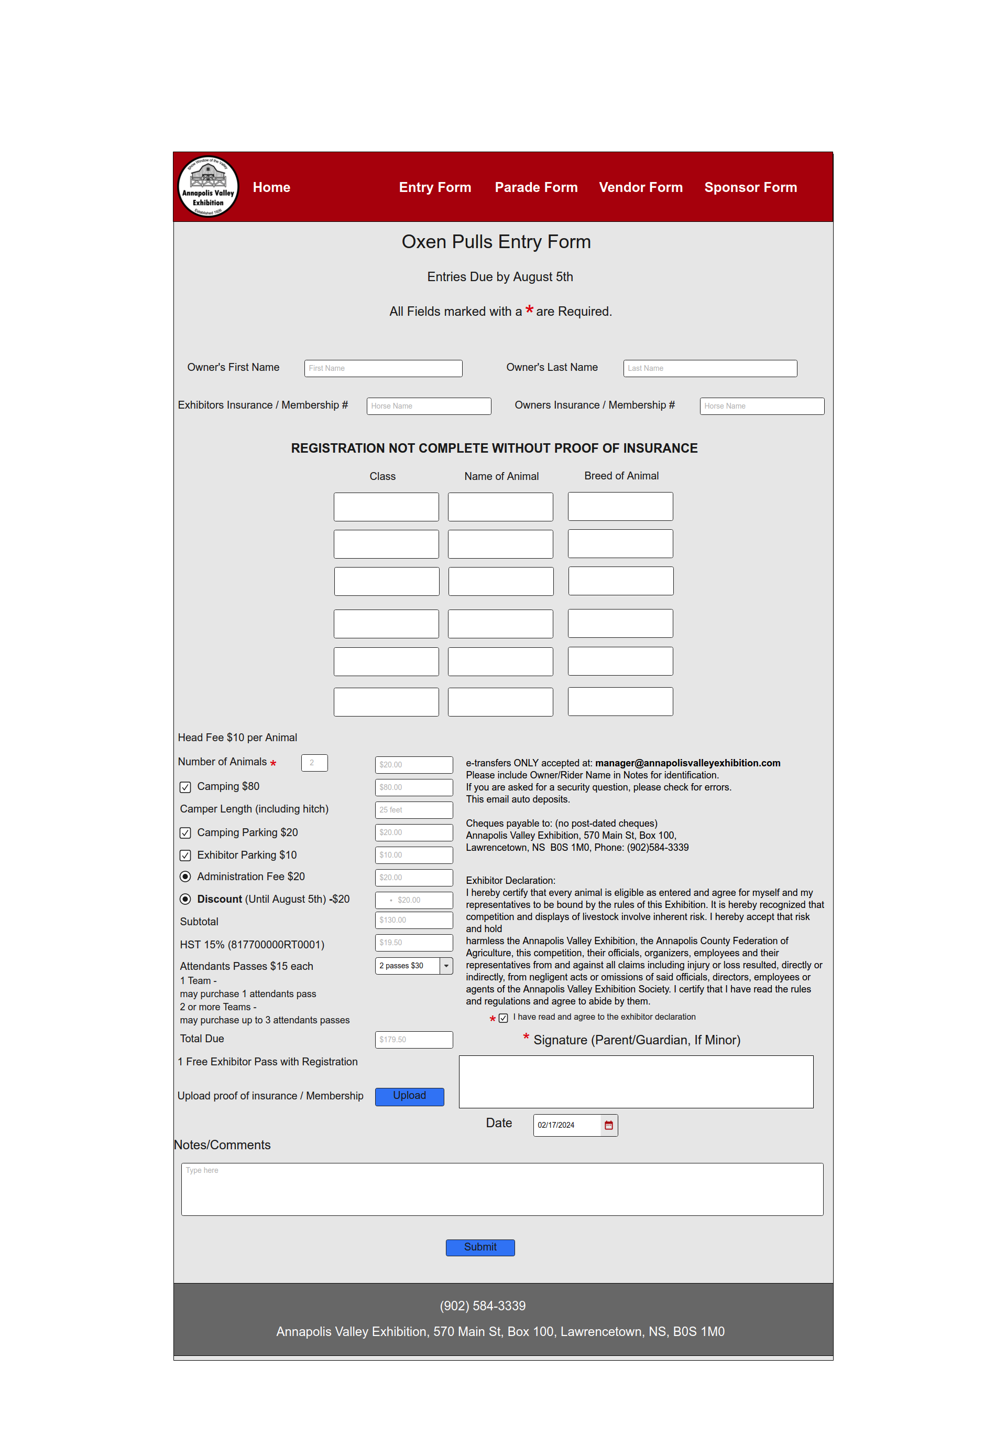

### Appendix F-8. Mini/Pleasure Driving Entry Form Mockup

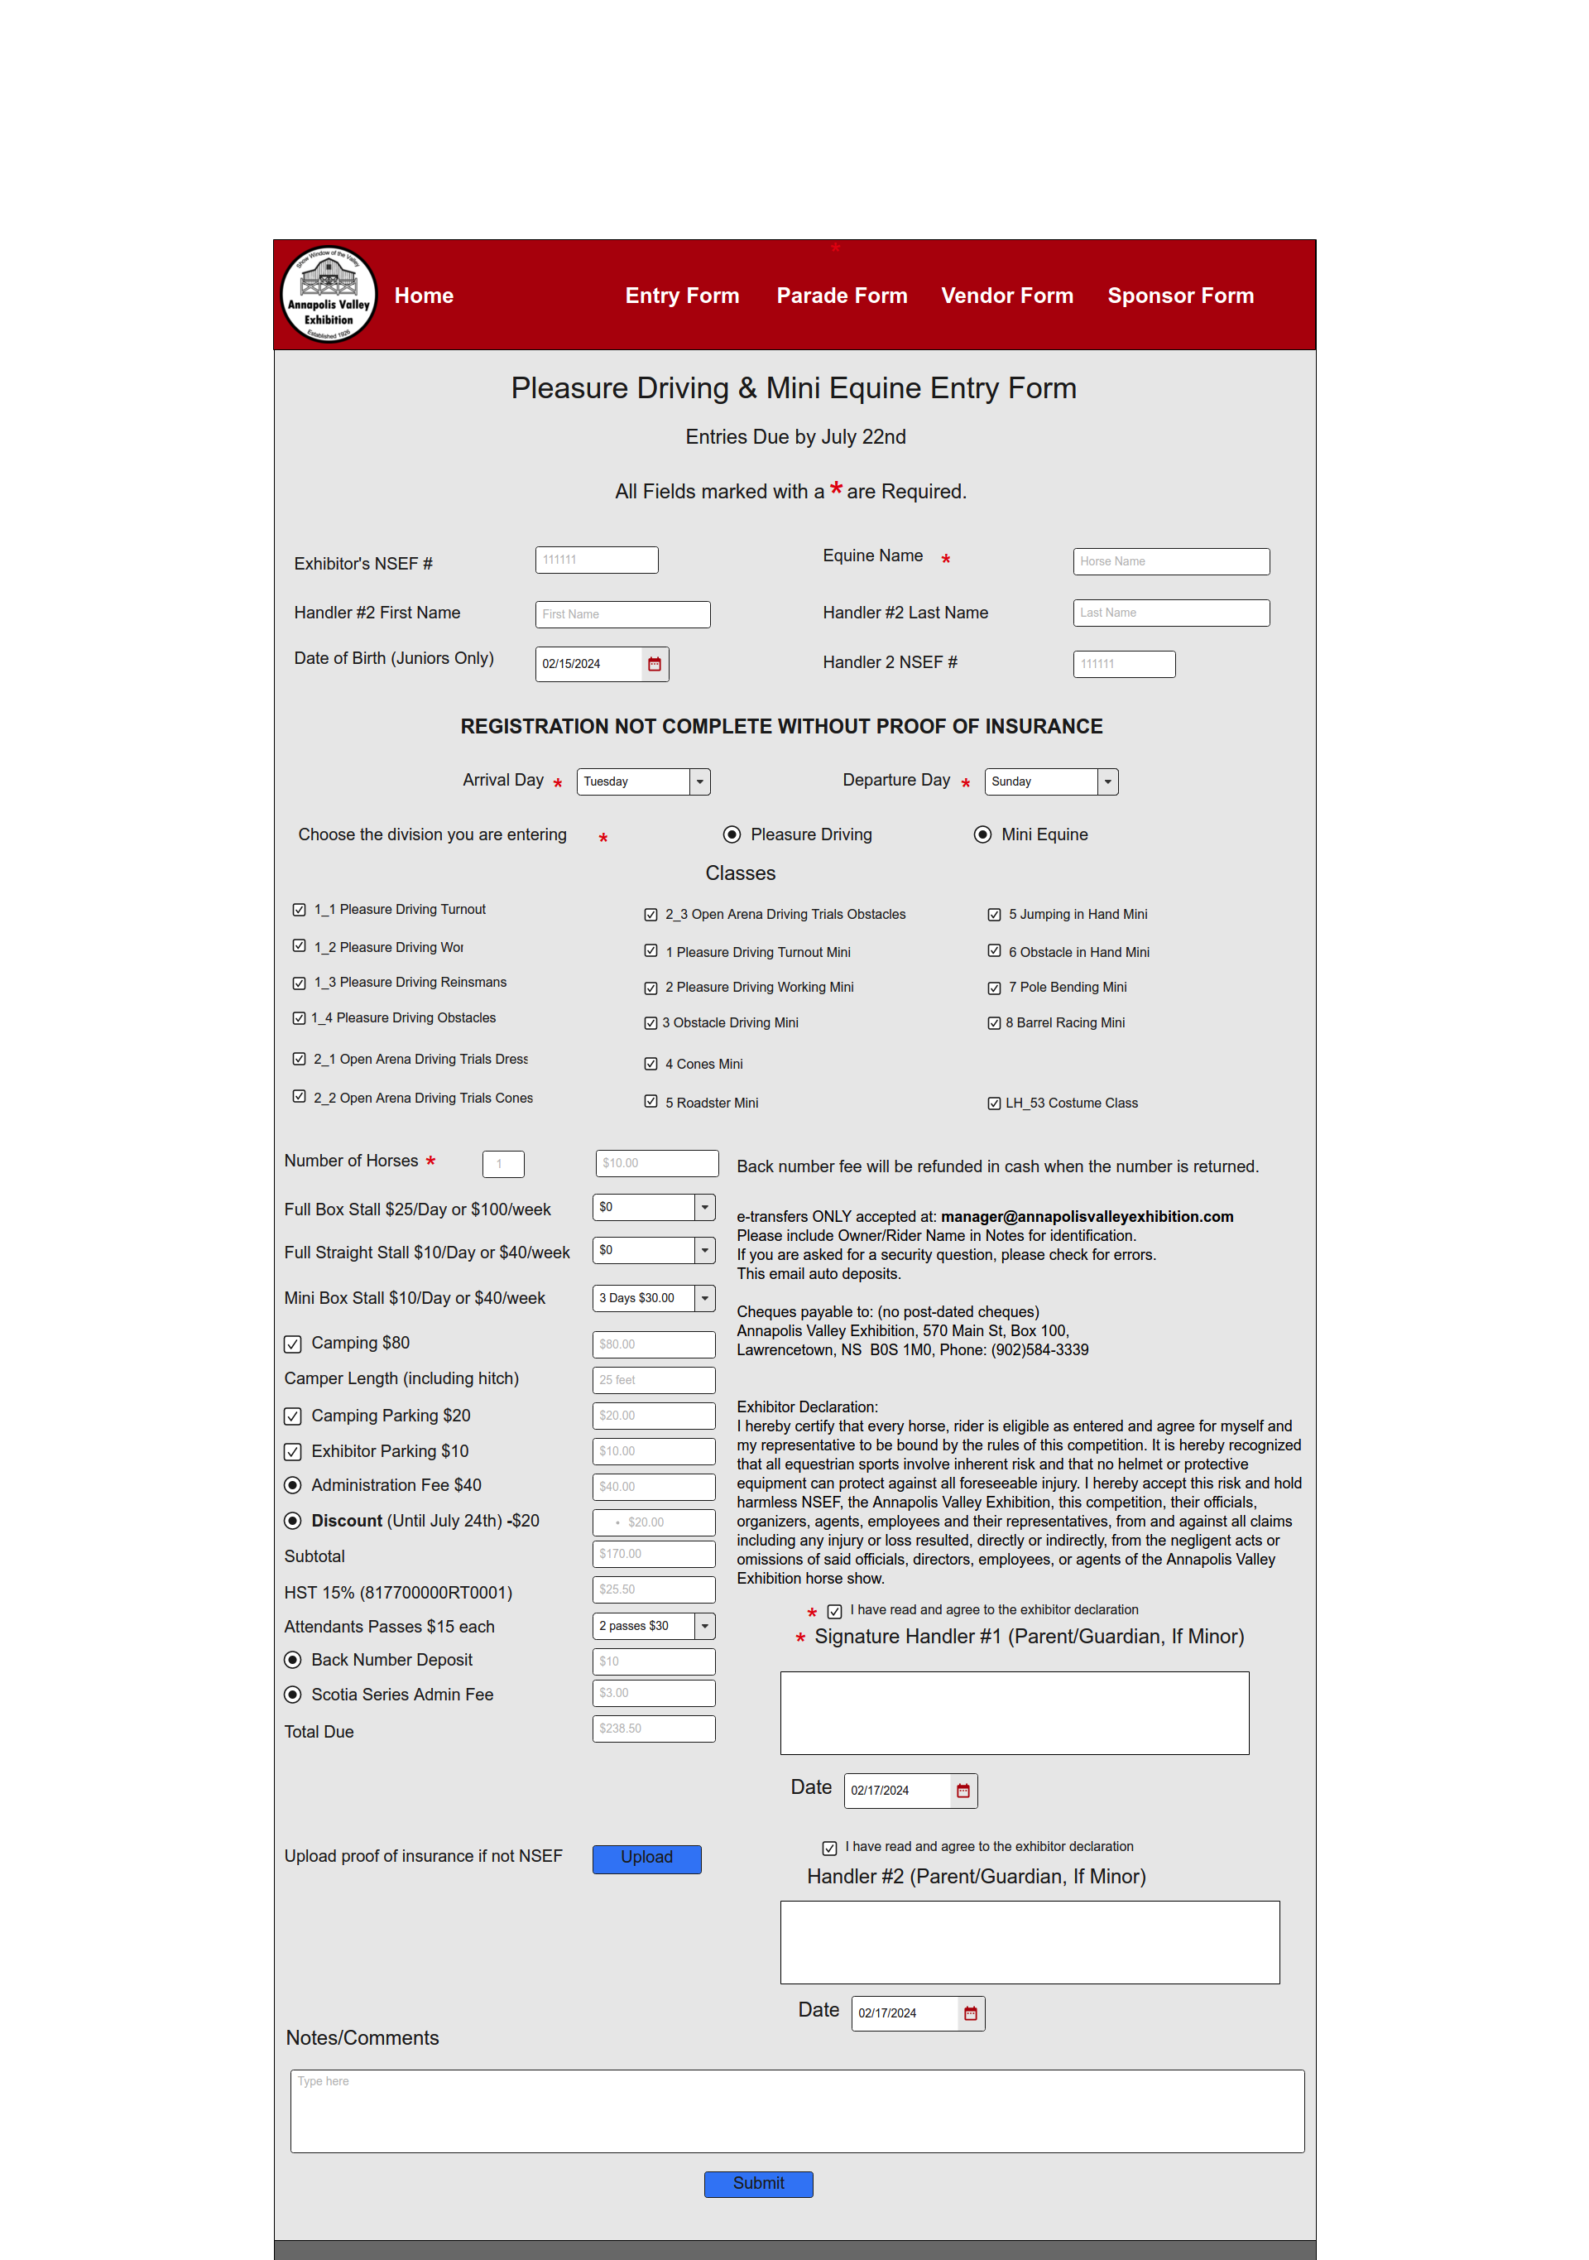

### Appendix F-9. Haflinger Entry Form Mockup

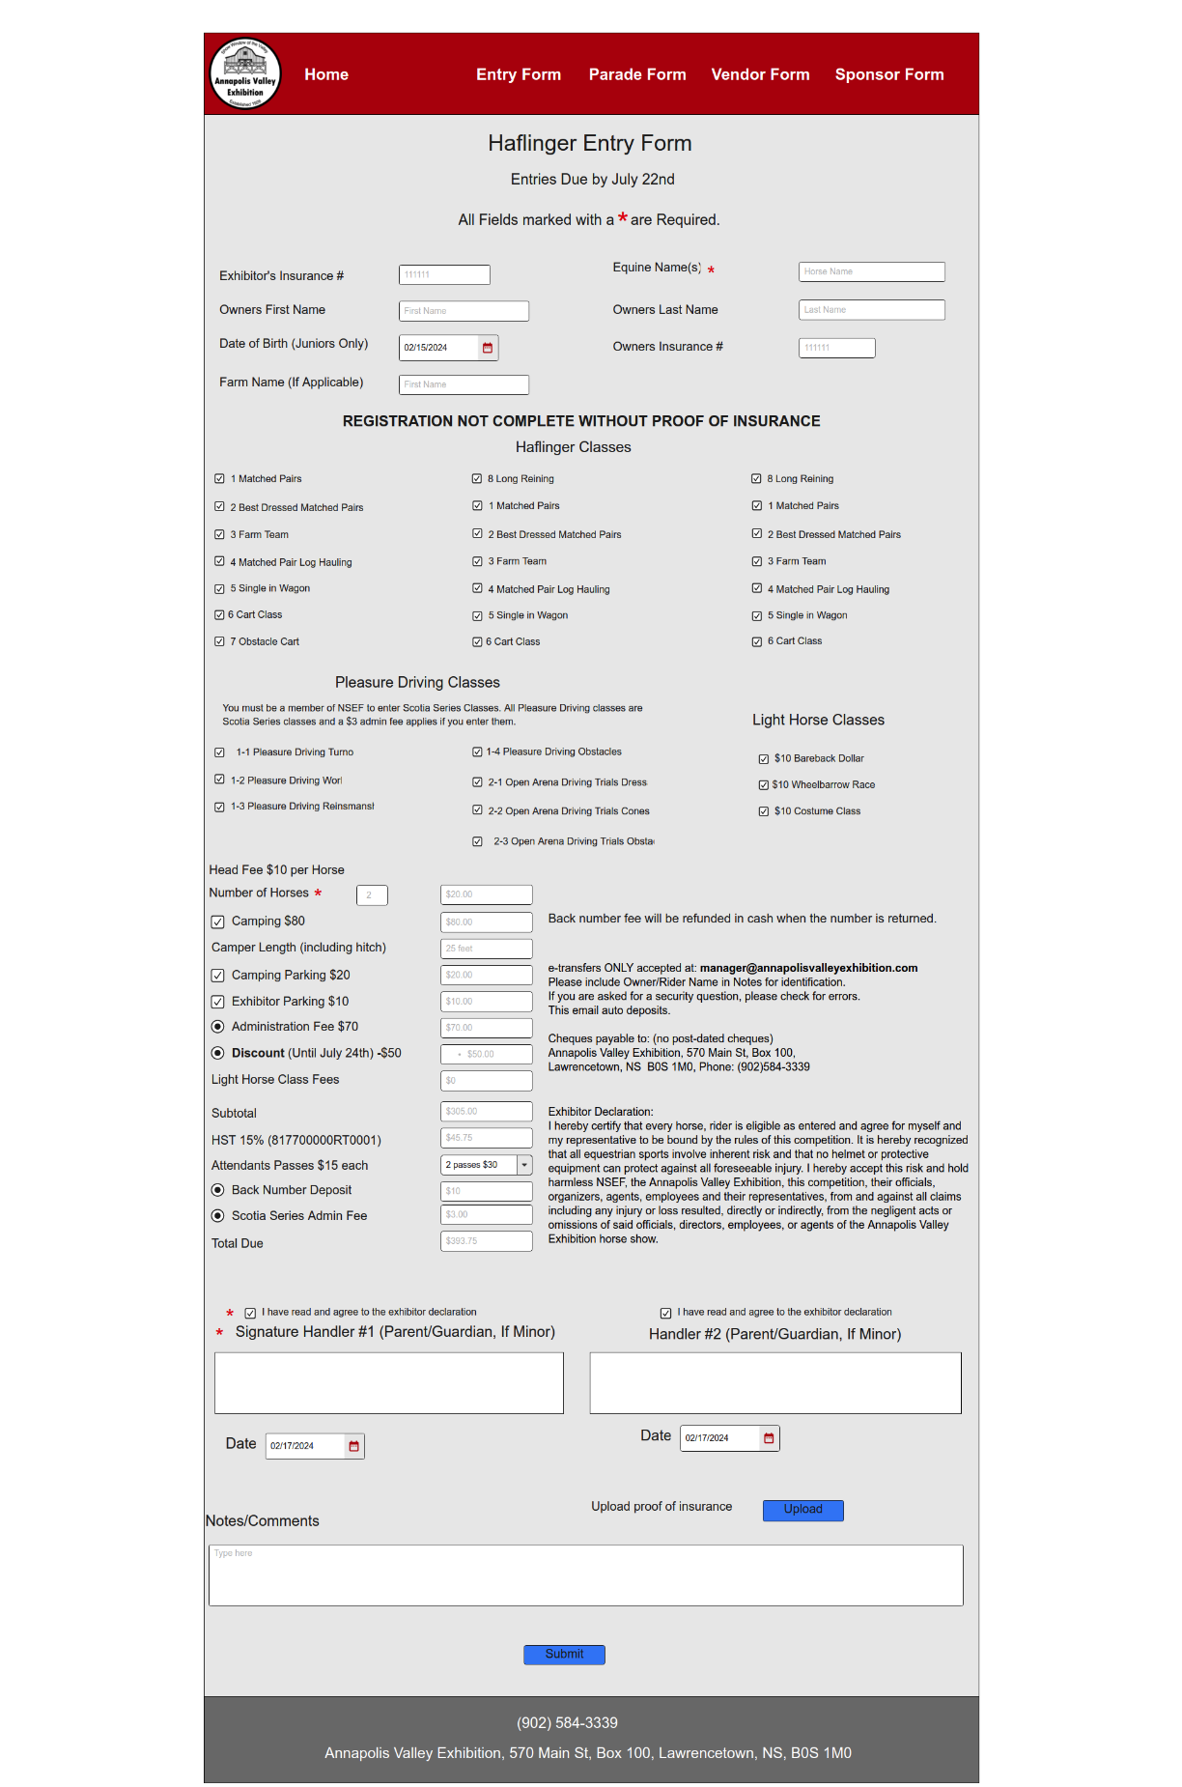

### Appendix F-10. Beef Entry Form Mockup

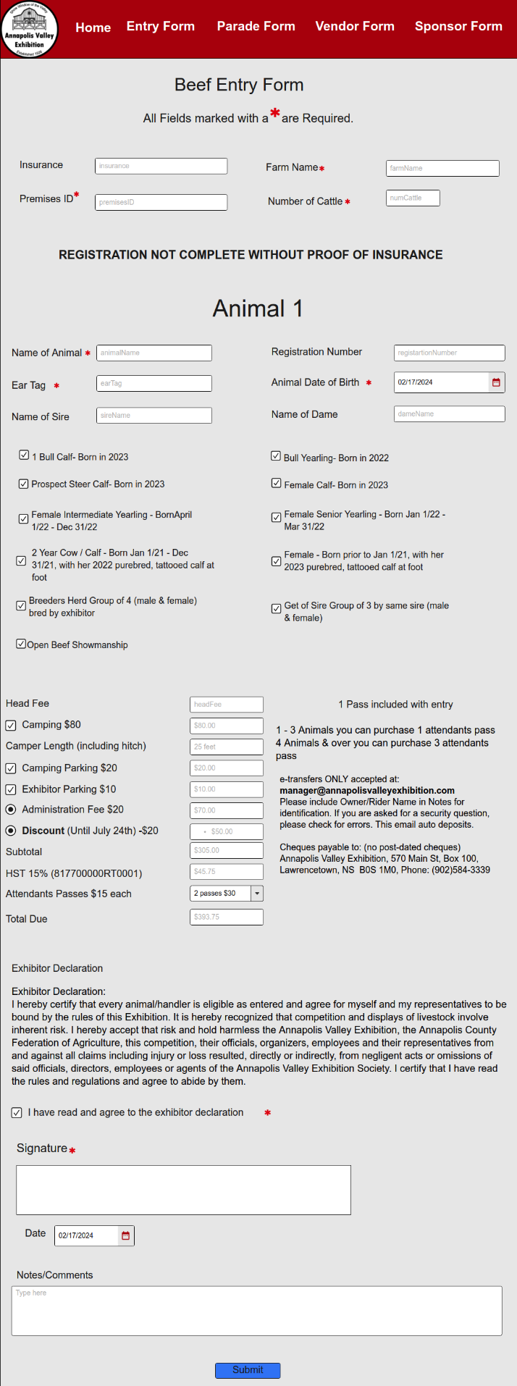

### Appendix F-11.Submission Confirmation (Entry) Mockup

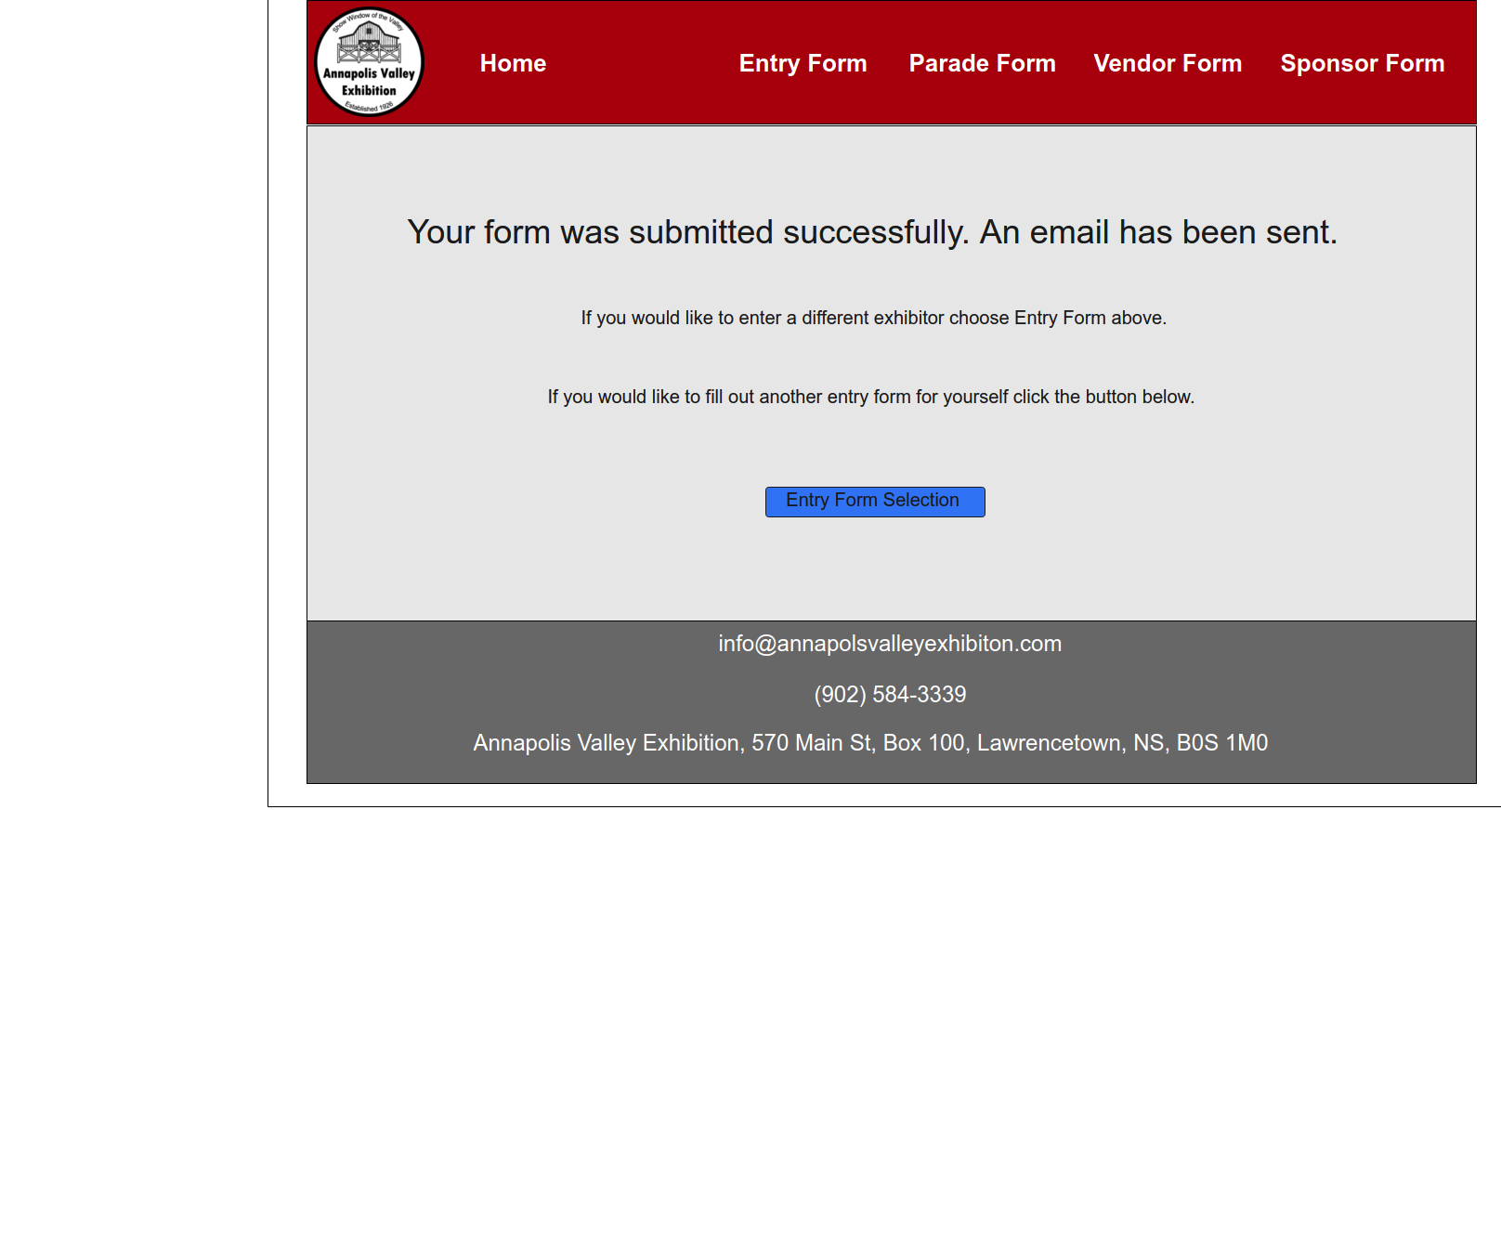

### Appendix F-12. Vendor Form Mockup

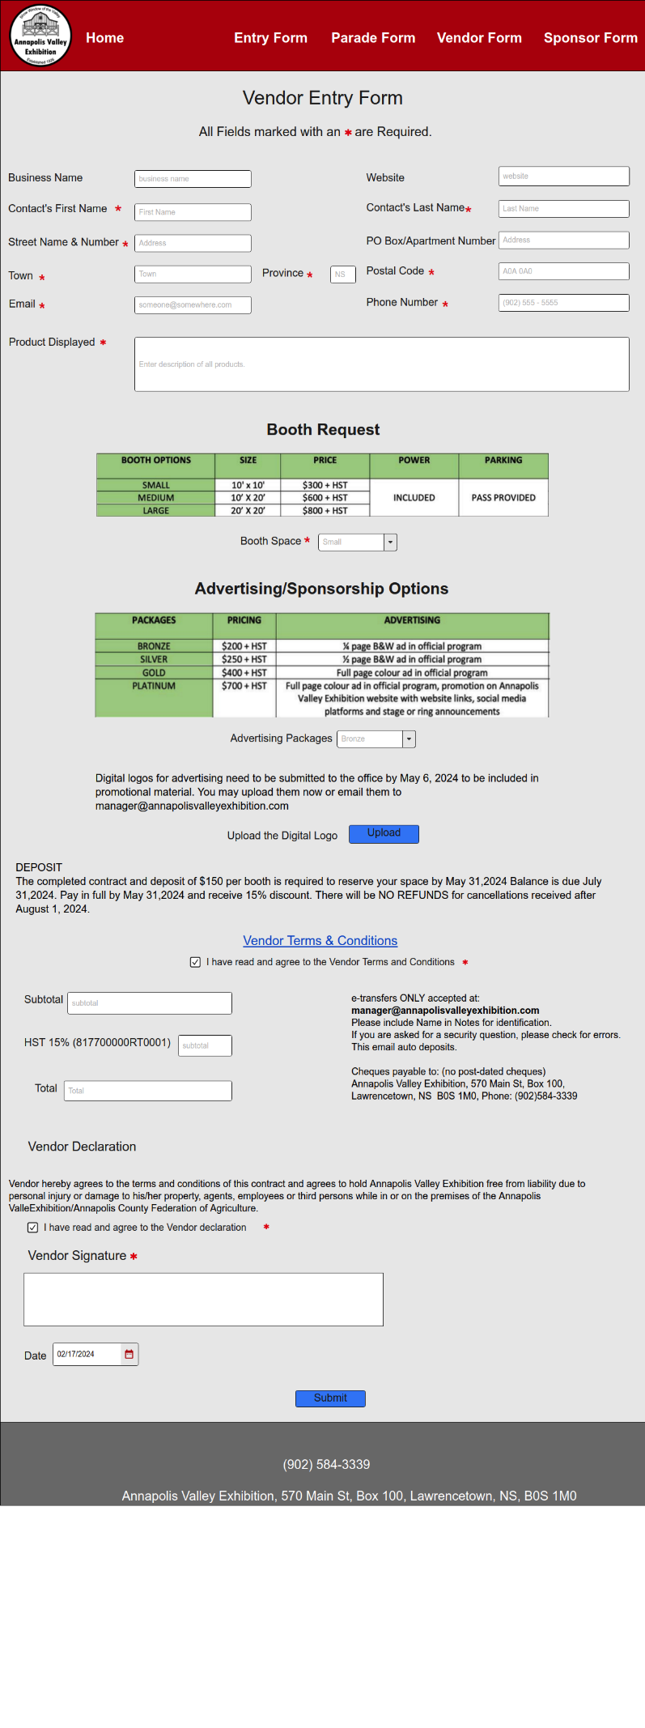

### Appendix F-13. Sponsor Form Mockup

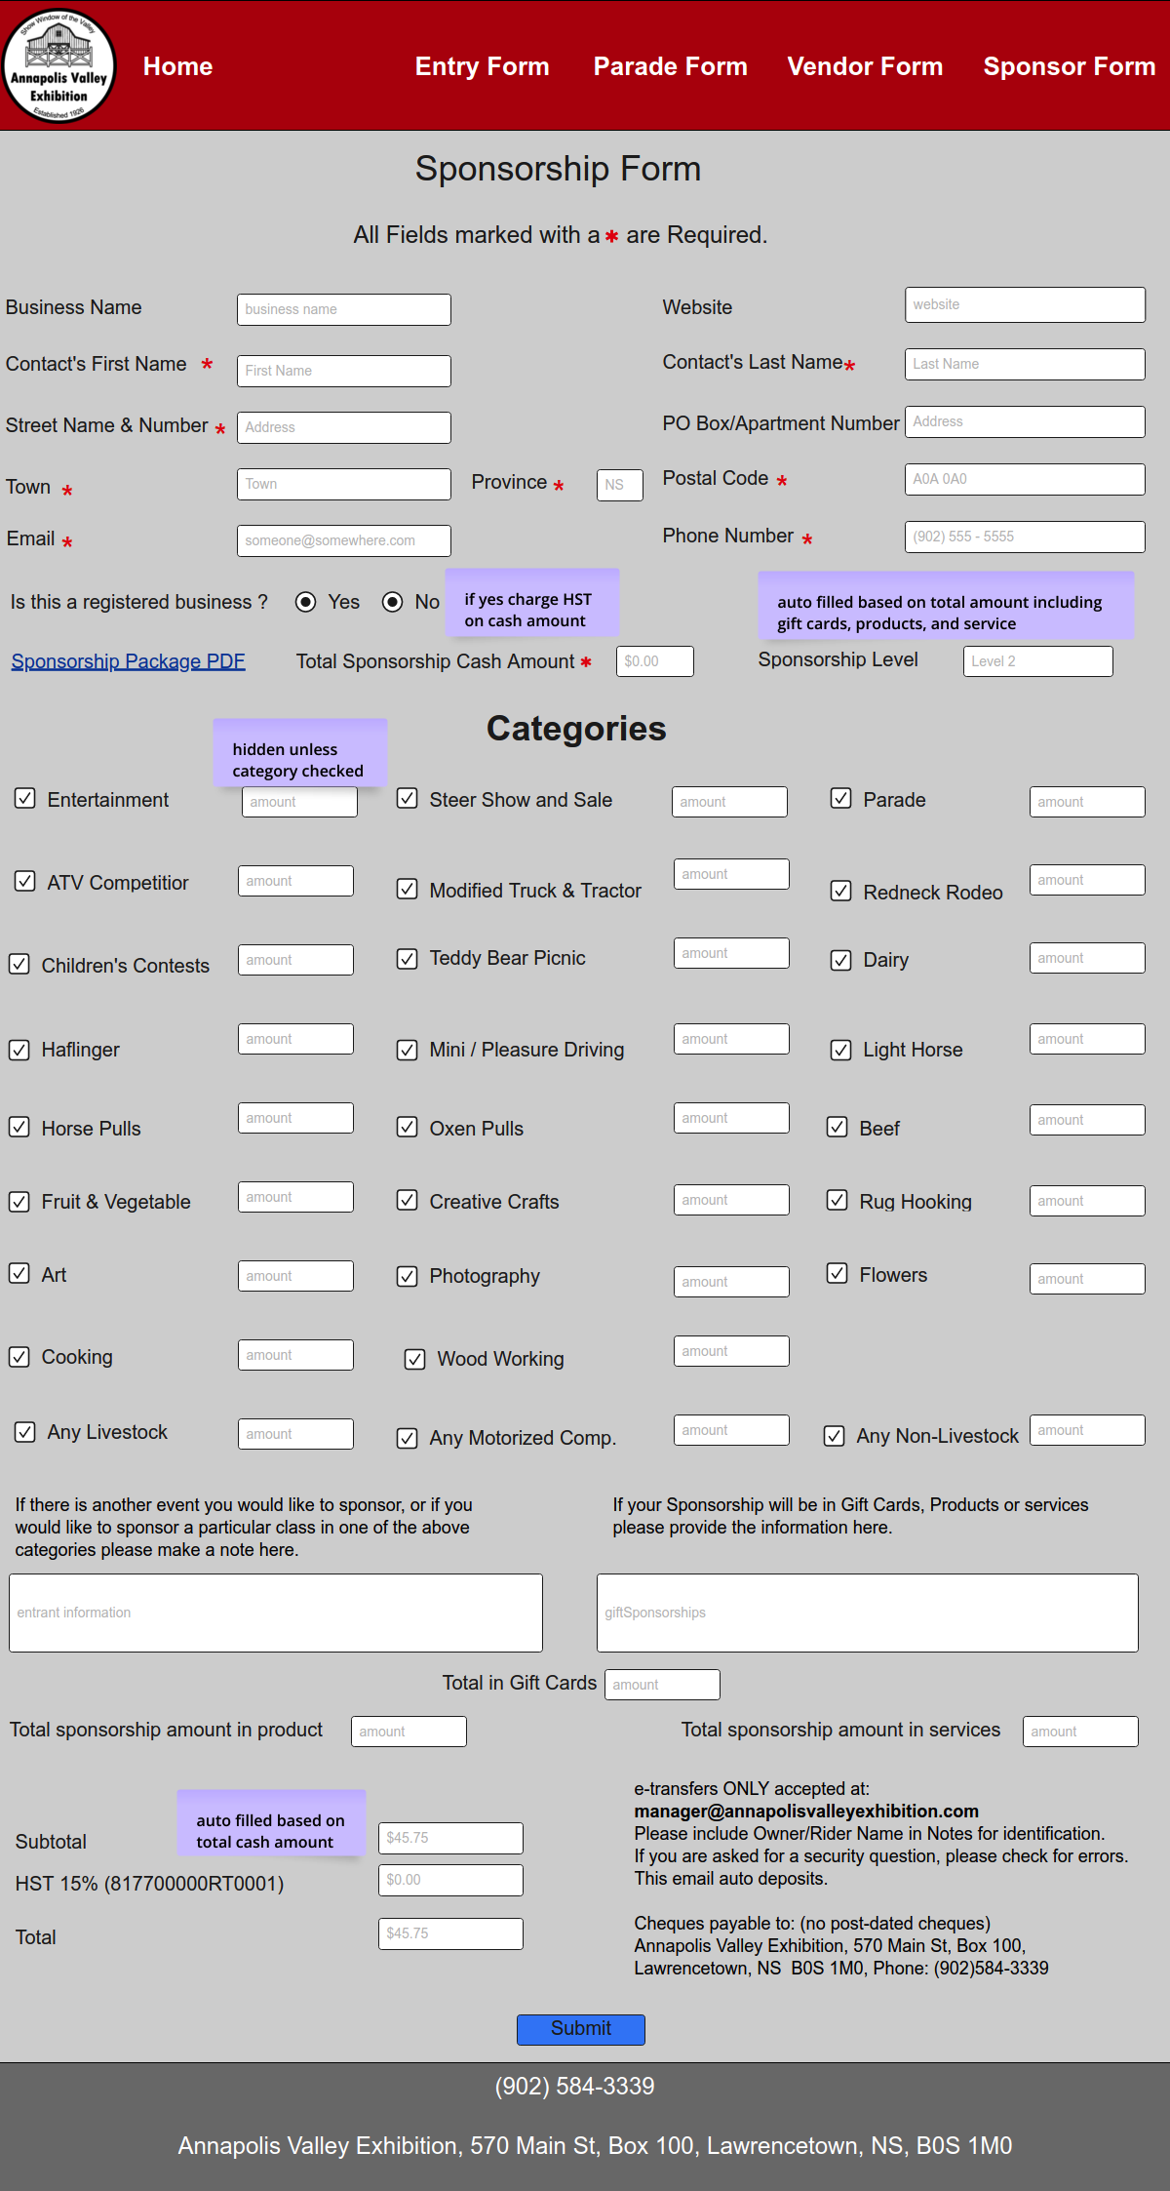

### Appendix F-14 Parade Form Mockup

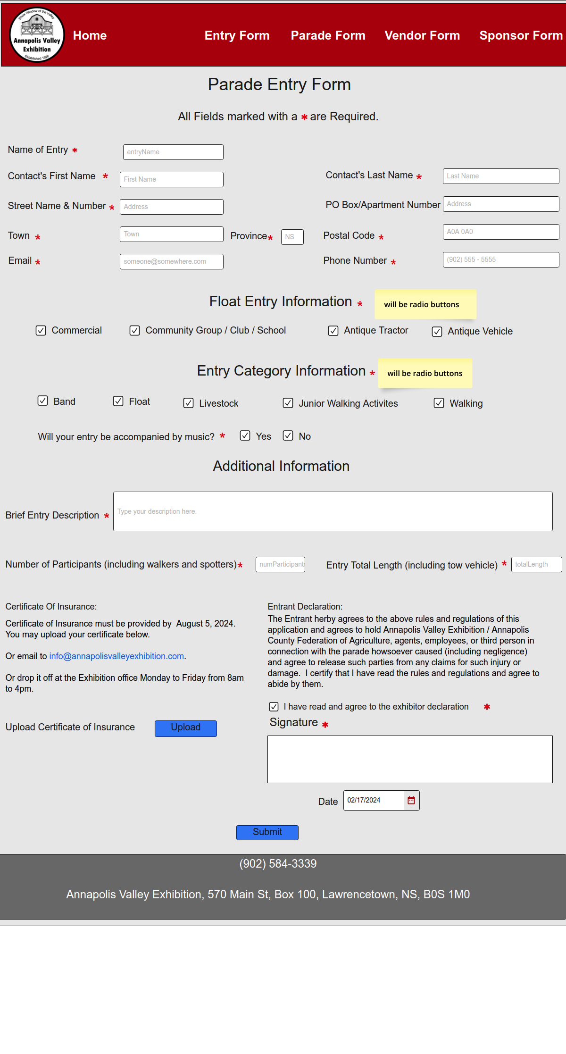

### Appendix F-15. Submission Confirmation (Other) Mockup

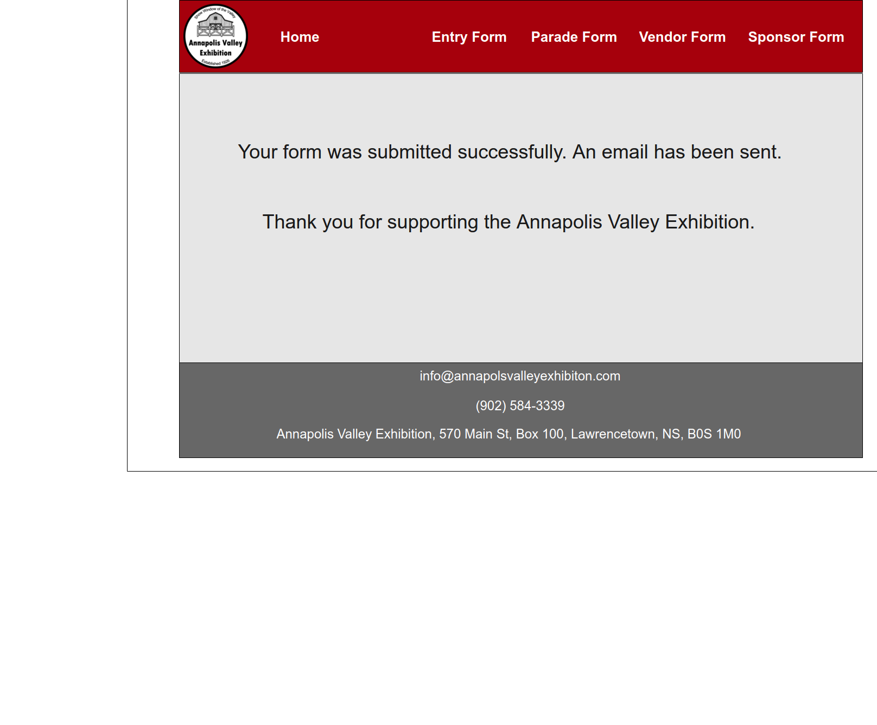

### Appendix F-16. Office Login Mockup

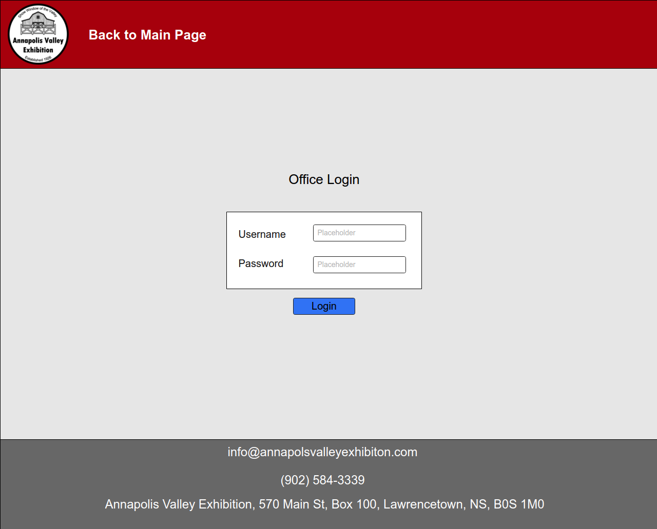

### Appendix F-17. Office Home Mockup



### Appendix F-18. Office – Create Schedule Mockup

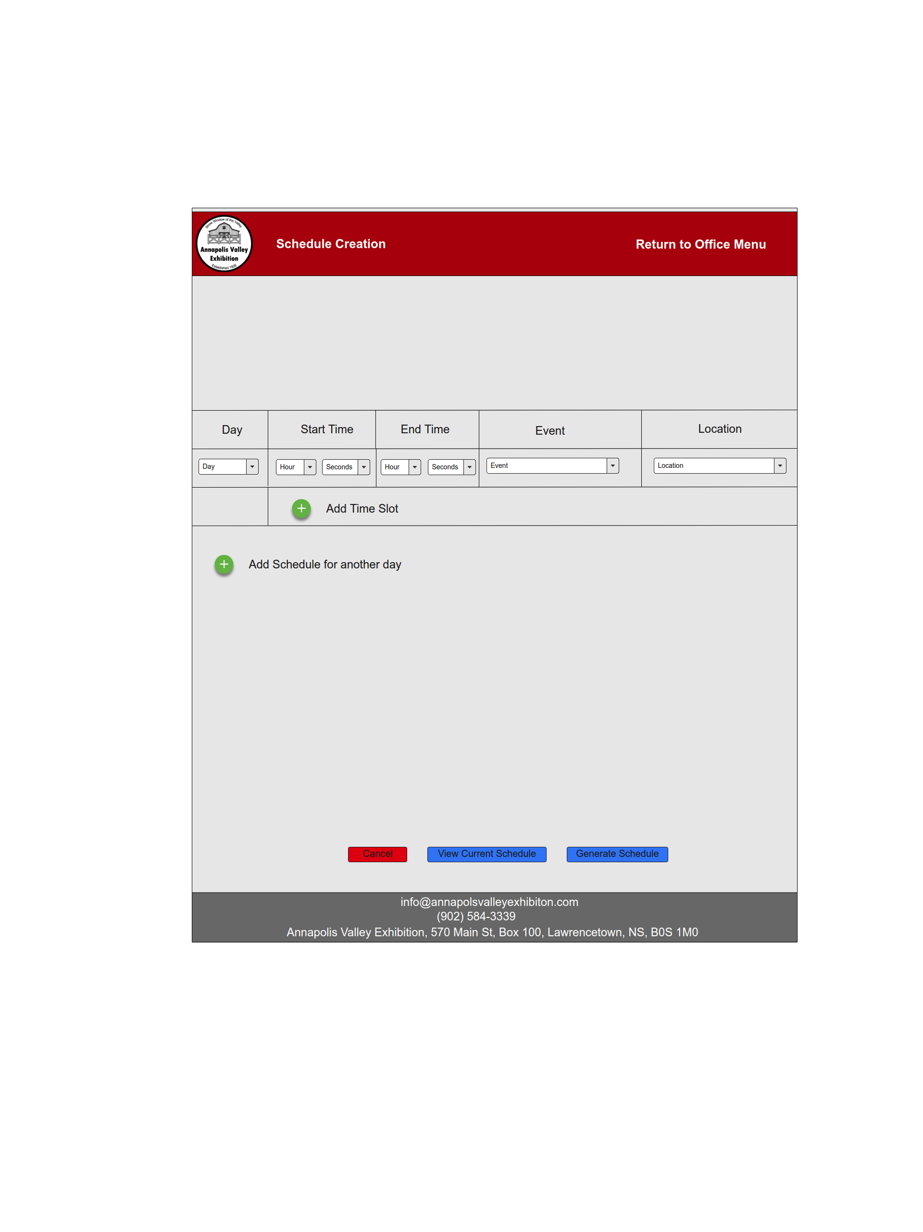

### Appendix F-19.Office - Edit Form Mockup

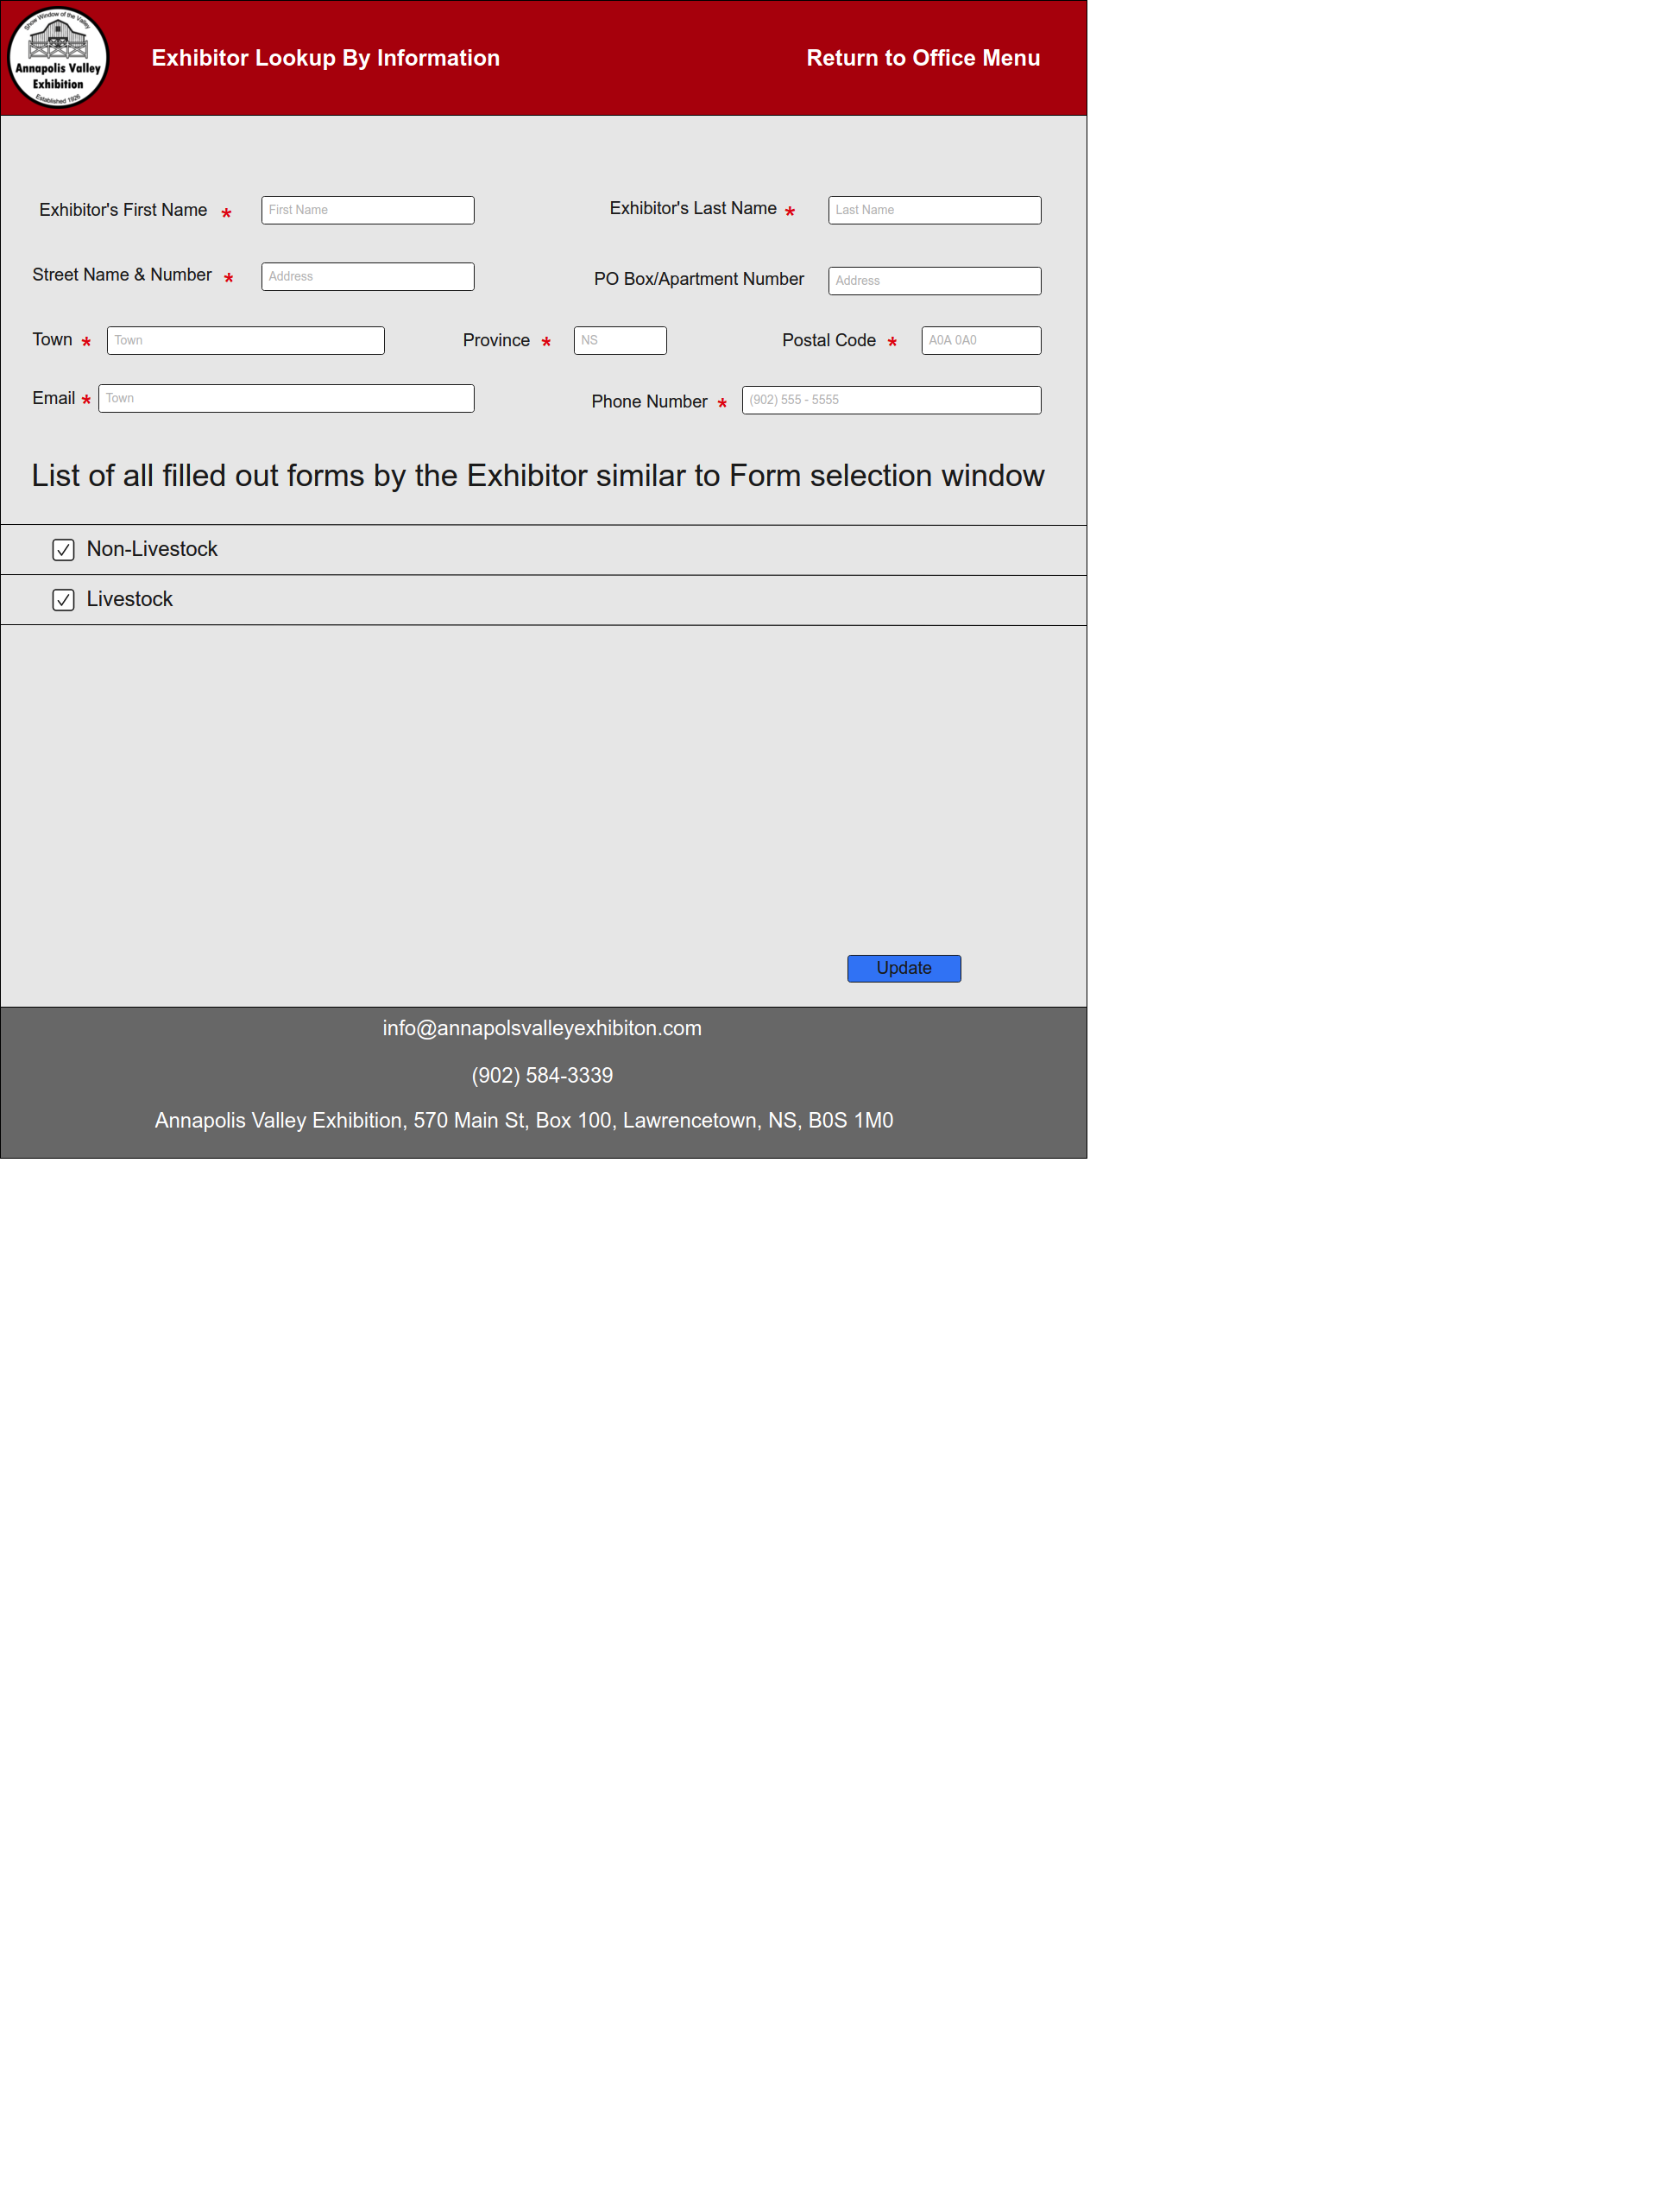

### Appendix F-20. Sponsor Contribution Mockup

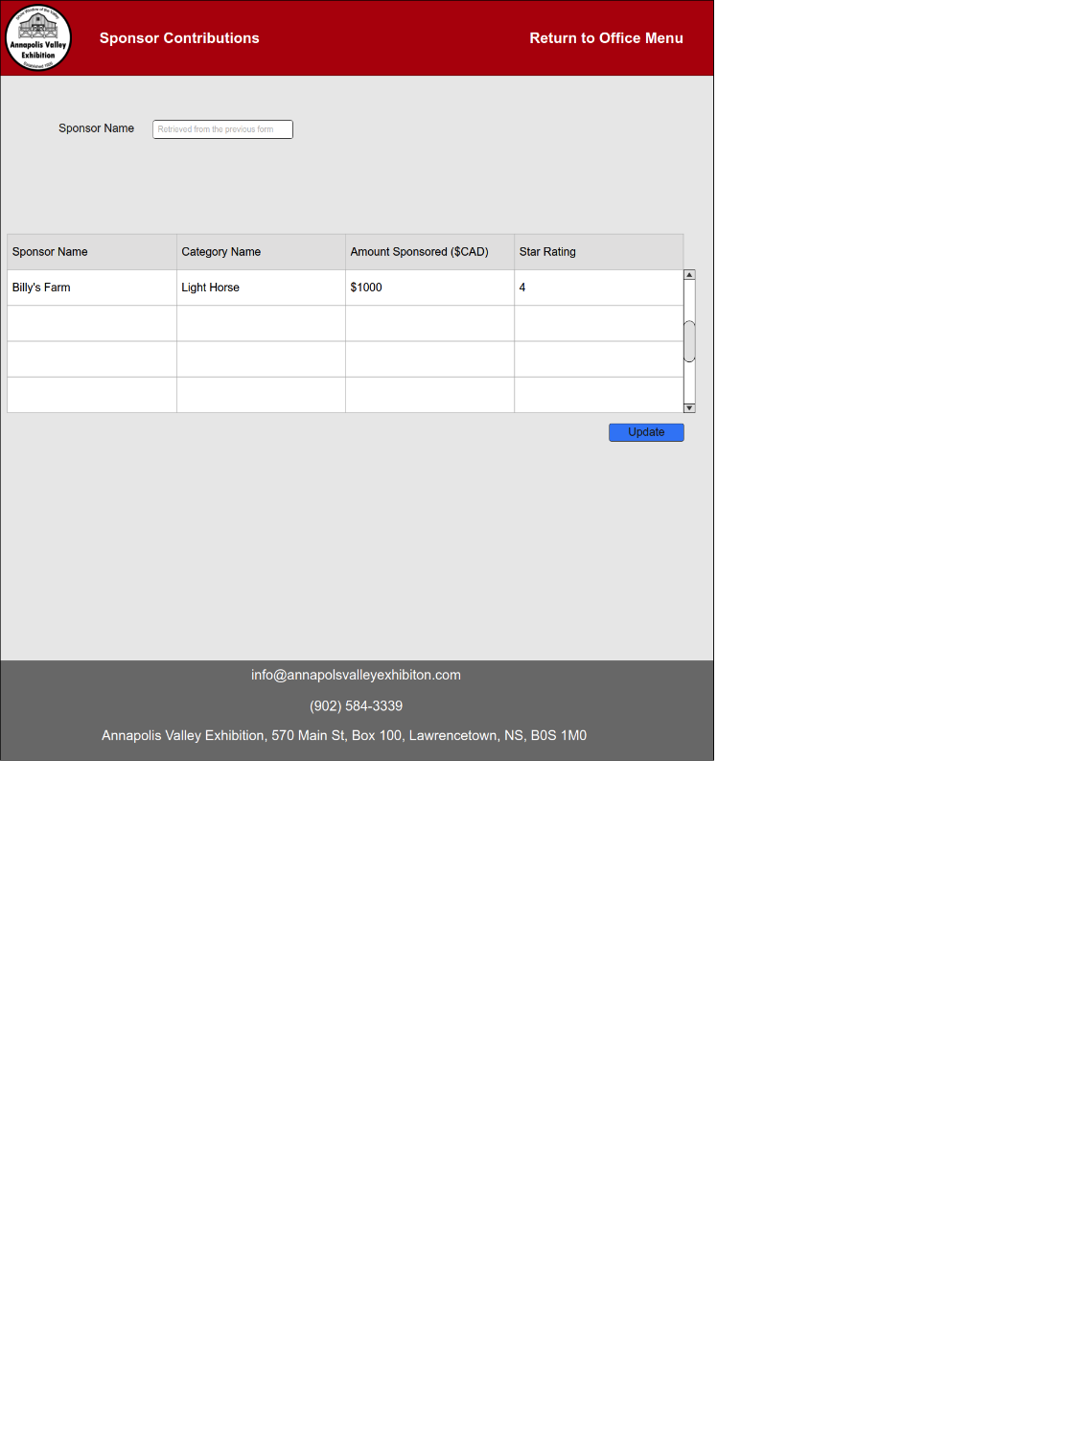

### Appendix F-21. Sponsor Search Mockup

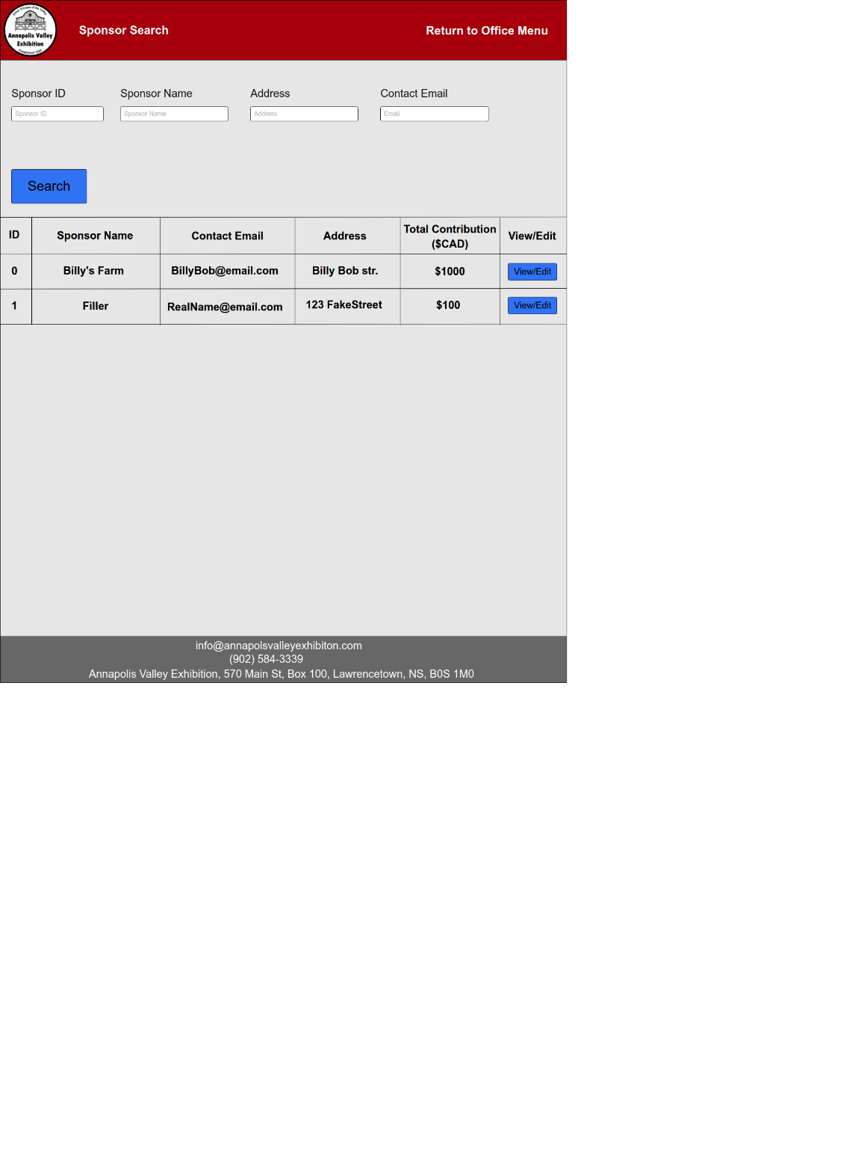

### Appendix F-22. Category Total Sponsorship Mockup

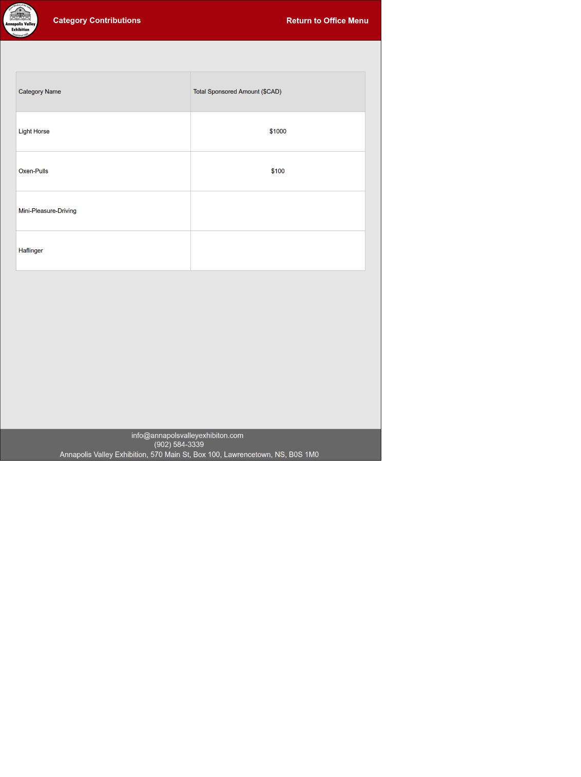

### Appendix F-23. Entry Lookup by Name Mockup

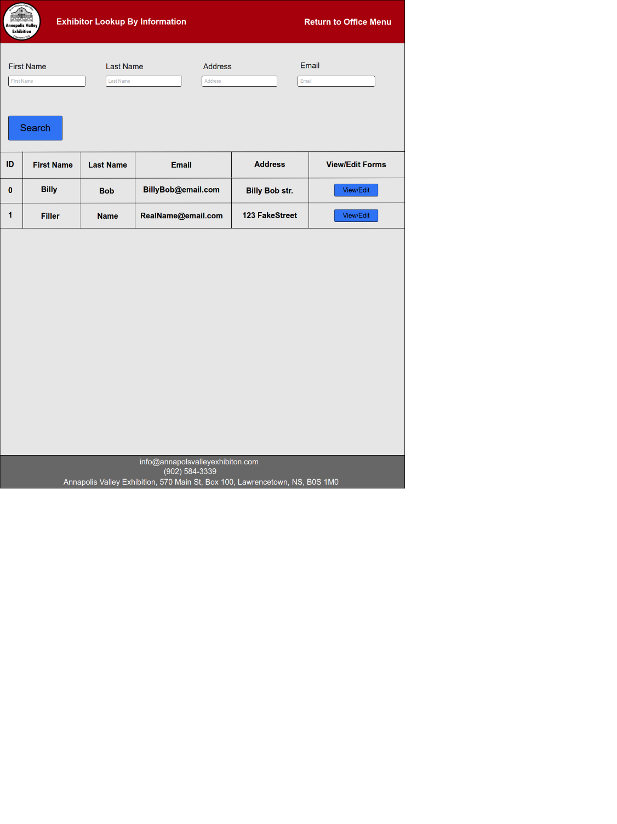

### Appendix F-24. Entry Lookup by ID Mockup

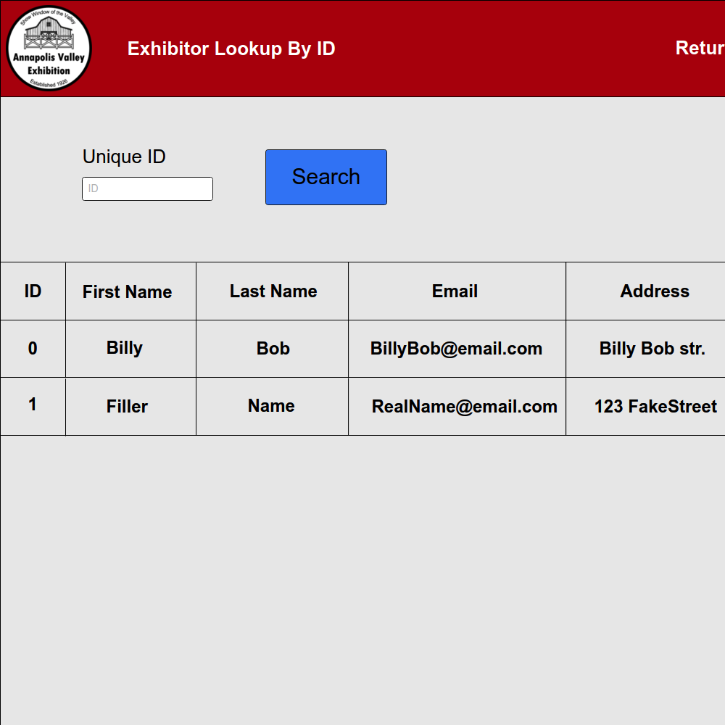

### Appendix F-25. Invoice Home (Lookup) Mockup

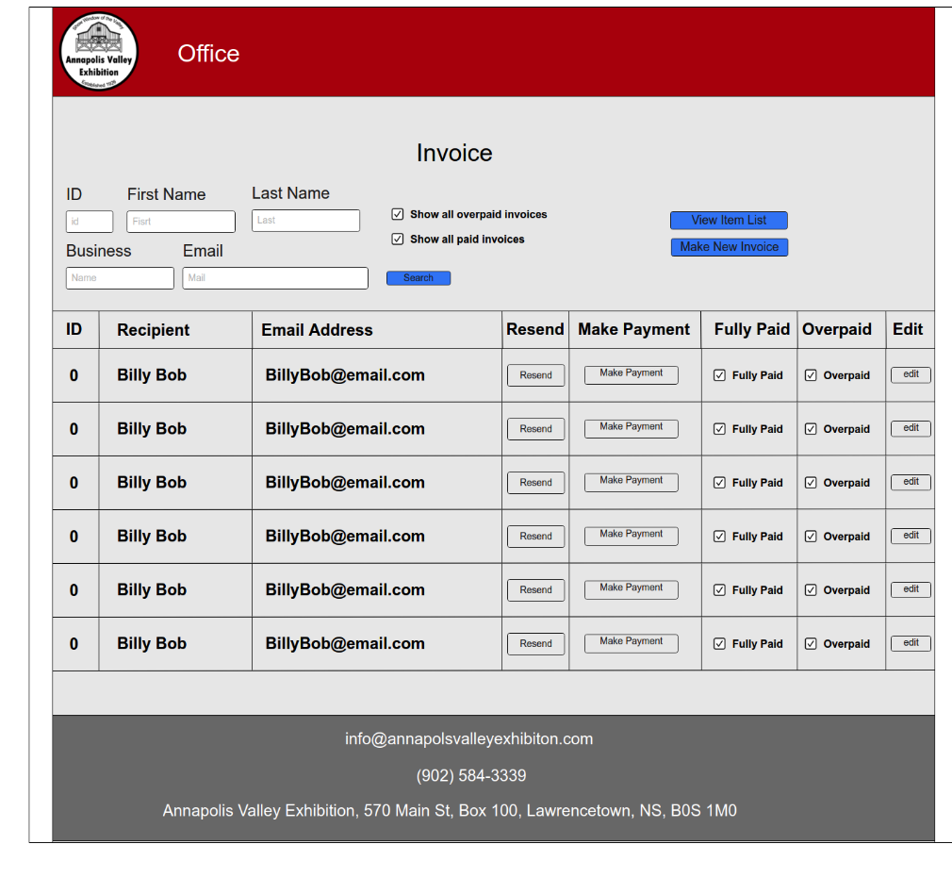

### Appendix F-26. Invoice - Create Mockup

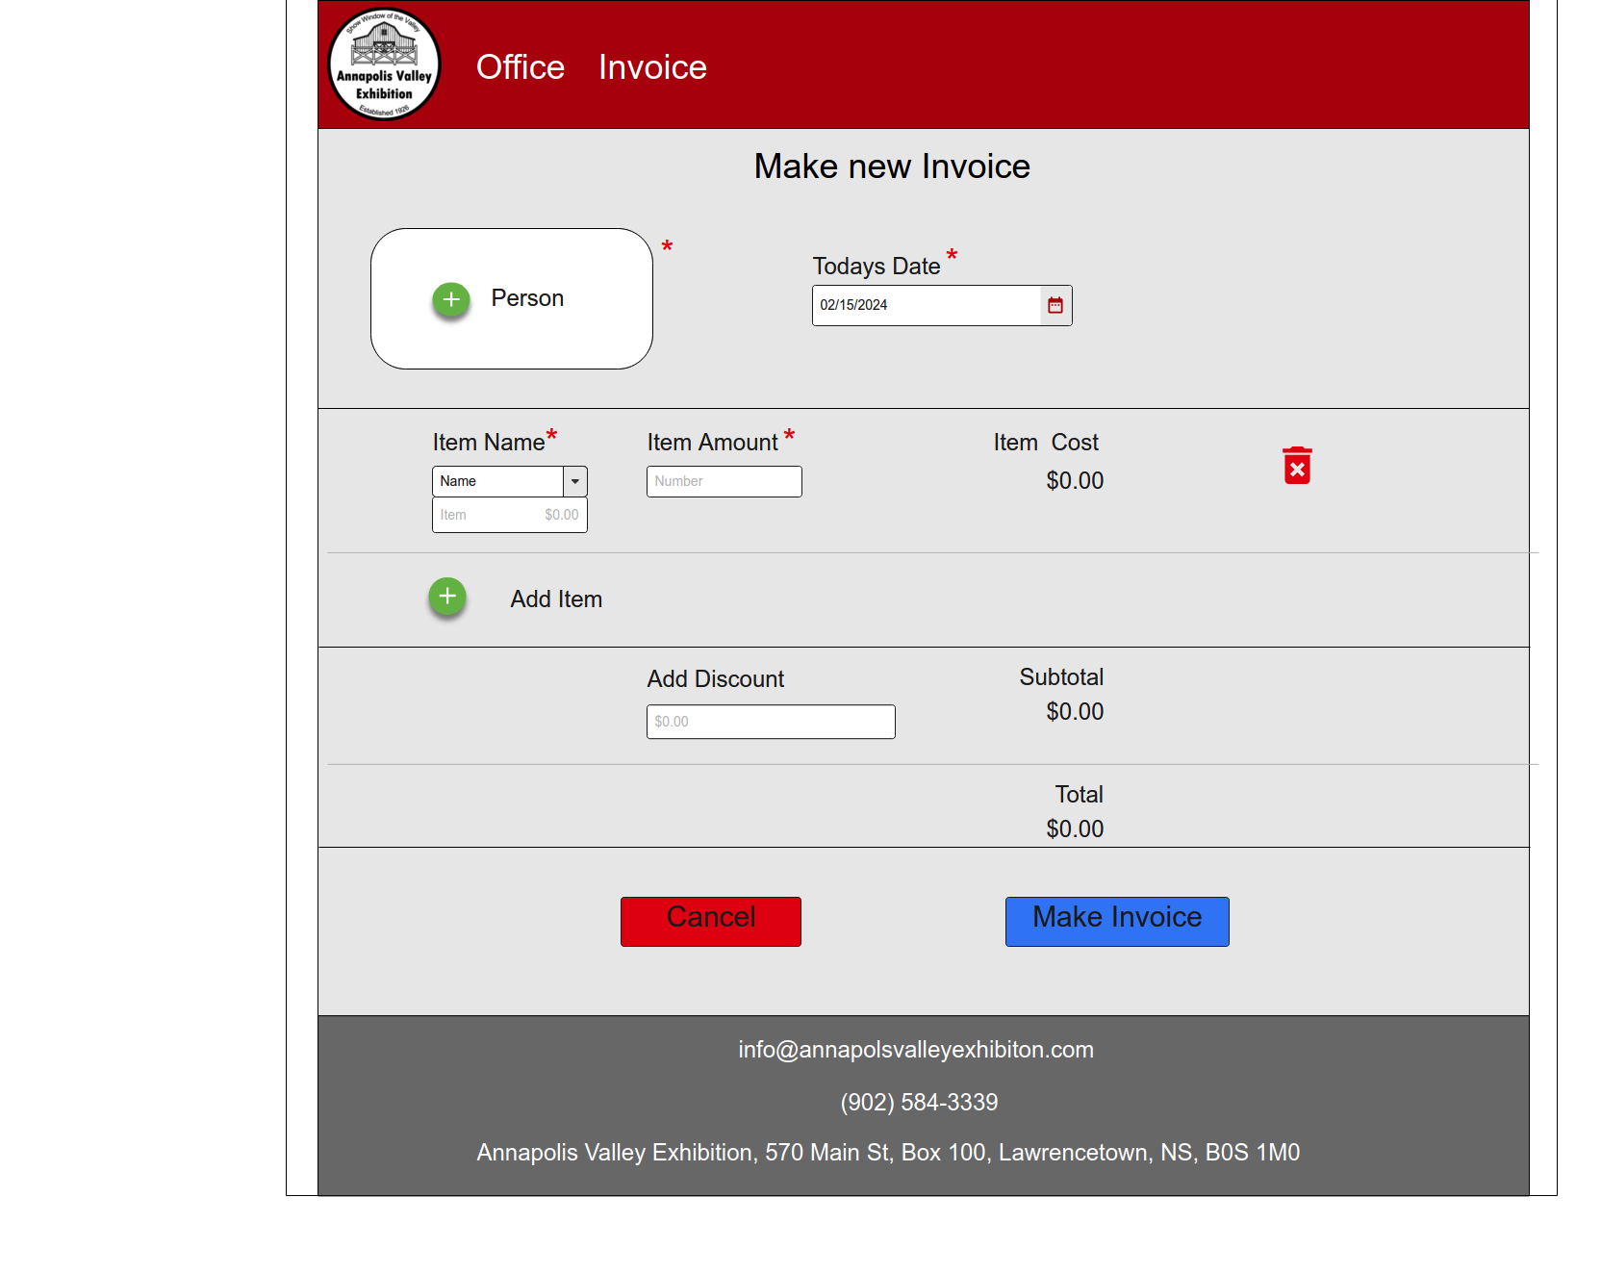

### Appendix F-27. Invoice – Invoice – Confirm / Print

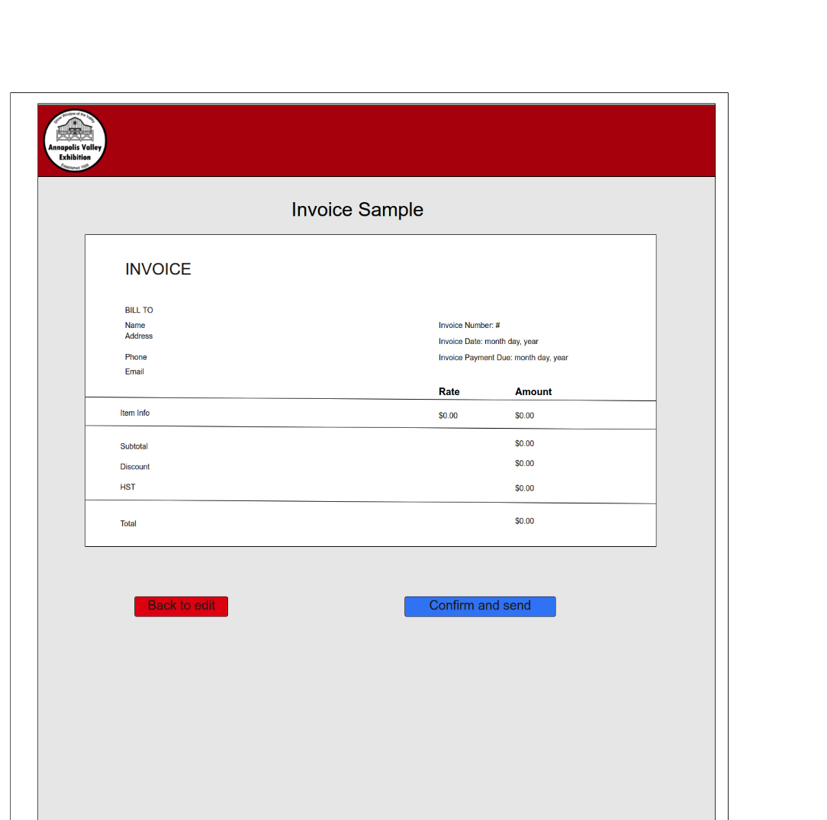

### Appendix F-28. Invoice – Add Person Mockup

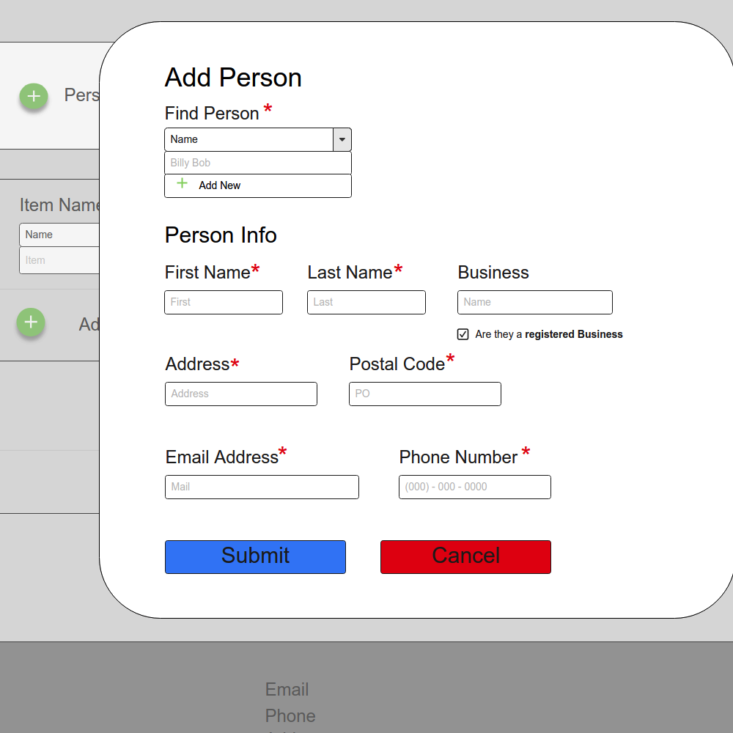

### Appendix F-29. Invoice – Record Payment Mockup

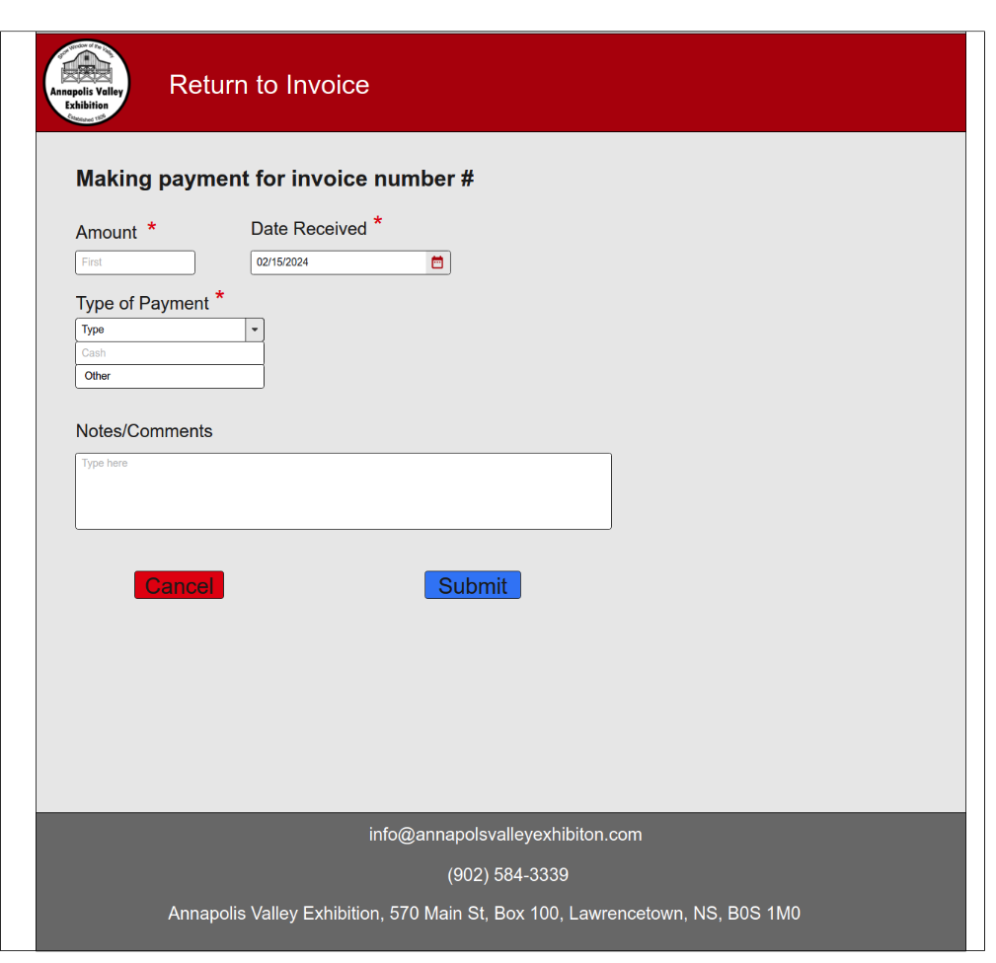

### Appendix F-30. Invoice – Add Item Mockup

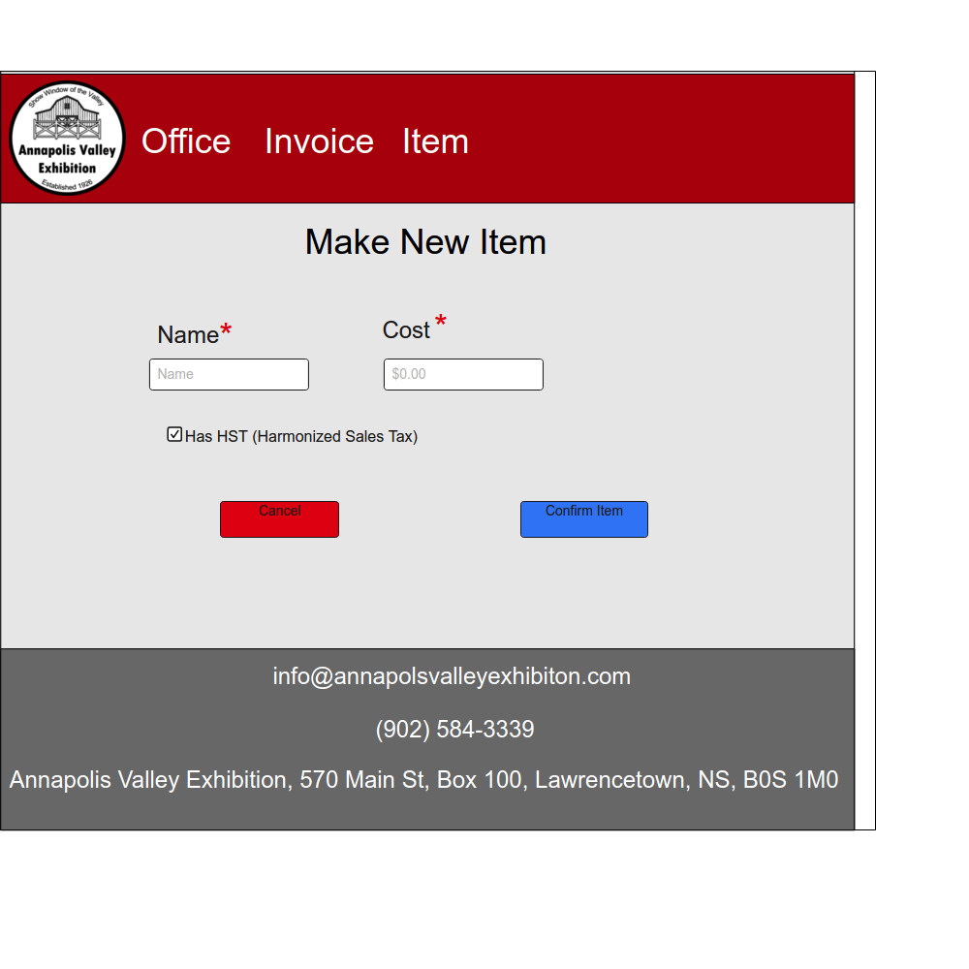

### Appendix G. ERD

[EIS ERD Link](HighLevelERD.pdf)

### Appendix H. Jira (Work Breakdown)

|  |  |  |  |  |  |  |  |
| --- | --- | --- | --- | --- | --- | --- | --- |
| Key | Issue Type | Parent | Summary | Status | Assignee | Start date | Due date |
| EIS-3 | Epic |  | Group Meetings | In Progress |  | 2024-01-10 | 2024-04-12 |
| EIS-27 | Task | EIS-3 | Group Meeting 1 | Done | Michele | 2024-01-08 | 2024-01-08 |
| EIS-24 | Task | EIS-3 | Group Meeting 2 | Done | Michele | 2024-01-10 | 2024-01-10 |
| EIS-25 | Task | EIS-3 | Group Meeting 3 | Done | JD | 2024-01-15 | 2024-01-15 |
| EIS-26 | Task | EIS-3 | Group Meeting 4 | Done | JD | 2024-01-17 | 2024-01-17 |
| EIS-64 | Task | EIS-3 | Group Meeting 5 | Done | Noah Taylor | 2024-01-24 | 2024-01-24 |
| EIS-99 | Task | EIS-3 | Group Meeting 6 | Done | Nathan | 2024-01-29 | 2024-01-29 |
| EIS-100 | Task | EIS-3 | Group Meeting 7 | Done |  | 2024-01-31 | 2024-01-31 |
| EIS-101 | Task | EIS-3 | Group Meeting 8 | Done | Michele | 2024-02-05 | 2024-02-05 |
| EIS-103 | Task | EIS-3 | Group Meeting 9 | Done |  | 2024-02-07 | 2024-02-07 |
| EIS-104 | Task | EIS-3 | Group Meeting 10 | Done |  | 2024-02-12 | 2024-02-12 |
| EIS-105 | Task | EIS-3 | Group Meeting 11 | Done |  | 2024-02-14 | 2024-02-14 |
| EIS-106 | Task | EIS-3 | Group Meeting 12 | To Do |  | 2024-02-19 | 2024-02-19 |
| EIS-107 | Task | EIS-3 | Group Meeting 13 | To Do |  | 2024-02-21 | 2024-02-21 |
| EIS-108 | Task | EIS-3 | Group Meeting 14 | To Do |  | 2024-02-26 | 2024-02-26 |
| EIS-109 | Task | EIS-3 | Group Meeting 15 | To Do |  | 2024-02-28 | 2024-02-28 |
| EIS-110 | Task | EIS-3 | Group Meeting 16 | To Do |  | 2024-03-04 | 2024-03-04 |
| EIS-111 | Task | EIS-3 | Group Meeting 17 | To Do |  | 2024-03-06 | 2024-03-06 |
| EIS-112 | Task | EIS-3 | Group Meeting 18 | To Do |  | 2024-03-11 | 2024-03-11 |
| EIS-113 | Task | EIS-3 | Group Meeting 19 | To Do |  | 2024-03-13 | 2024-03-13 |
| EIS-114 | Task | EIS-3 | Group Meeting 20 | To Do |  | 2024-03-18 | 2024-03-18 |
| EIS-115 | Task | EIS-3 | Group Meeting 21 | To Do |  | 2024-03-20 | 2024-03-20 |
| EIS-116 | Task | EIS-3 | Group Meeting 22 | To Do |  | 2024-03-25 | 2024-03-25 |
| EIS-117 | Task | EIS-3 | Group Meeting 23 | To Do |  | 2024-03-27 | 2024-03-27 |
| EIS-118 | Task | EIS-3 | Group Meeting 24 | To Do |  | 2024-04-01 | 2024-04-01 |
| EIS-119 | Task | EIS-3 | Group Meeting 25 | To Do |  | 2024-04-03 | 2024-04-03 |
| EIS-120 | Task | EIS-3 | Group Meeting 26 | To Do |  | 2024-04-08 | 2024-04-08 |
| EIS-121 | Task | EIS-3 | Group Meeting 27 | To Do |  | 2024-04-10 | 2024-04-10 |
| EIS-40 | Epic |  | Project Administration | In Progress |  |  |  |
| EIS-39 | Task | EIS-40 | Time Sheet Update | Done | JD | 2024-01-14 | 2024-01-14 |
| EIS-41 | Task | EIS-40 | Setting Up Jira | Done | JD | 2024-01-17 | 2024-02-08 |
| EIS-42 | Task | EIS-40 | Setup Projects Github Repo | Done | JD | 2024-02-15 | 2024-02-15 |
| EIS-68 | Task | EIS-40 | Submit documents to the Exhibition Board and Committees | In Progress | Michele | 2024-01-13 | 2024-01-13 |
| EIS-85 | Task | EIS-40 | Adding a Status Field to the excel spreadsheet | Done | JD | 2024-01-22 | 2024-01-22 |
| EIS-122 | Task | EIS-40 | Edit Proposal | To Do | Michele | 2024-01-05 | 2024-01-24 |
| EIS-123 | Task | EIS-40 | Send Proposal to Exhibition Board | To Do | Michele | 2024-01-25 | 2024-01-25 |
| EIS-128 | Task | EIS-40 | Submit proposal | Done | Michele | 2024-01-22 | 2024-01-22 |
| EIS-135 | Task | EIS-40 | Confidentiality Agreements for Team Members | Done | Michele | 2024-01-19 | 2024-01-22 |
| EIS-136 | Task | EIS-40 | Create Intellectual Property Agreement for System | In Progress | Michele | 2024-01-22 | 2024-02-16 |
| EIS-137 | Task | EIS-40 | Contact the Stakeholders | In Progress | Michele | 2024-01-12 | 2024-04-06 |
| EIS-138 | Task | EIS-40 | Prepare for Meetings | In Progress | Michele | 2024-01-08 | 2024-04-12 |
| EIS-202 | Task | EIS-40 | Change Control Document Overview | To Do | JD | 2024-02-10 | 2024-04-12 |
| EIS-207 | Task | EIS-40 | Individual check ins and updates | To Do | Michele | 2024-02-04 | 2024-03-31 |
| EIS-208 | Task | EIS-40 | Review Submitted documents and diagrams | To Do | Michele | 2024-02-04 | 2024-04-12 |
| EIS-214 | Task | EIS-40 | Update Personal Tasks and Timesheet | To Do |  |  |  |
| EIS-65 | Epic |  | Define Requirements / Information Gathering | In Progress | Michele | 2024-01-08 | 2024-03-22 |
| EIS-37 | Task | EIS-65 | Research Invoice System | Done | Liam Morton | 2024-01-17 | 2024-01-31 |
| EIS-66 | Task | EIS-65 | Meet with President of the Board | Done | Michele | 2024-01-12 | 2024-01-12 |
| EIS-63 | Task | EIS-65 | Meet with VP of Exhibition Society | Done | Michele | 2024-01-19 | 2024-01-19 |
| EIS-67 | Task | EIS-65 | Meet with Board Member / Announcer | Done | Michele | 2024-01-22 | 2024-01-22 |
| EIS-133 | Task | EIS-65 | Talk to Simon | Done | Michele | 2024-01-31 | 2024-01-31 |
| EIS-134 | Task | EIS-65 | Acquire documents | In Progress | Michele | 2024-01-15 | 2024-02-09 |
| EIS-209 | Task | EIS-65 | Talk to committees | To Do |  | 2024-02-04 | 2024-03-22 |
| EIS-213 | Task | EIS-65 | Meet with Stakeholders | To Do |  |  |  |
| EIS-2 | Epic |  | Project Specification Document | In Progress | Michele | 2024-01-10 | 2024-03-19 |
| EIS-16 | Task | EIS-2 | Executive Summary | In Progress | Michele | 2024-01-10 | 2024-02-08 |
| EIS-17 | Task | EIS-2 | Project Description | In Progress | Michele | 2024-01-10 | 2024-02-08 |
| EIS-18 | Task | EIS-2 | System Components | In Progress | Michele | 2024-02-04 | 2024-02-08 |
| EIS-22 | Task | EIS-2 | Project Charter | In Progress | Khushpreet Singh | 2024-01-10 | 2024-02-08 |
| EIS-23 | Task | EIS-2 | Team Charter | In Progress | Michele | 2024-02-05 | 2024-02-08 |
| EIS-102 | Task | EIS-2 | Add Conduct a Cost Benefit Analysis to Doc | In Progress | Noah Taylor | 2024-01-24 | 2024-02-08 |
| EIS-149 | Task | EIS-2 | User Class and Characteristics Section | In Progress | Nathan | 2024-02-04 | 2024-02-08 |
| EIS-154 | Task | EIS-2 | Operating Environment | Done | Nathan | 2024-01-10 | 2024-02-08 |
| EIS-155 | Task | EIS-2 | Assumption Dependencies | In Progress | Nathan | 2024-01-10 | 2024-02-08 |
| EIS-156 | Task | EIS-2 | External Interface Requirements | Done | Liam Morton | 2024-02-03 | 2024-02-08 |
| EIS-161 | Task | EIS-2 | Non-Functional Requirements | To Do | JD | 2024-01-10 | 2024-02-08 |
| EIS-162 | Task | EIS-2 | Implementation Requirements | In Progress | Noah Taylor | 2024-02-05 | 2024-02-09 |
| EIS-167 | Task | EIS-2 | Time and Cost Estimates | In Progress | Michele | 2024-02-05 | 2024-02-08 |
| EIS-171 | Task | EIS-2 | Gantt Chart | In Progress | JD | 2024-02-06 | 2024-02-08 |
| EIS-172 | Task | EIS-2 | Pert Chart | To Do | JD | 2024-02-06 | 2024-02-08 |
| EIS-173 | Task | EIS-2 | Work Breakdown Structure | To Do | JD | 2024-02-06 | 2024-02-09 |
| EIS-174 | Task | EIS-2 | Risk assessment | To Do | Noah Taylor | 2024-02-05 | 2024-02-08 |
| EIS-175 | Task | EIS-2 | Communication Diagram | To Do | Michele | 2024-02-05 | 2024-02-08 |
| EIS-147 | Task | EIS-2 | Add Non-Livestock Form Layout to Doc | To Do | Noah Taylor | 2024-02-05 | 2024-02-09 |
| EIS-177 | Task | EIS-2 | Document Submission | Done | Michele |  | 2024-02-09 |
| EIS-215 | Task | EIS-2 | Update Project Specification Document | To Do |  |  |  |
| EIS-69 | Epic |  | Planning & Design | To Do | Michele | 2024-01-10 | 2024-03-11 |
| EIS-4 | Task | EIS-69 | Write Proposal | Done | Michele | 2024-01-08 | 2024-01-23 |
| EIS-84 | Task | EIS-69 | Add security proposal to project proposal | Done | Nathan | 2024-01-22 | 2024-01-23 |
| EIS-54 | Task | EIS-69 | Format the Proposal | Done | Michele | 2024-01-05 | 2024-01-23 |
| EIS-72 | Task | EIS-69 | Outline of all livestock views | In Progress | Michele | 2024-01-22 | 2024-02-08 |
| EIS-73 | Task | EIS-69 | Outline of all non-livestock views | In Progress | Noah Taylor | 2024-01-22 | 2024-02-08 |
| EIS-126 | Task | EIS-69 | Cost benefit analysis for web hosting | In Progress | Noah Taylor | 2024-01-24 | 2024-02-08 |
| EIS-74 | Task | EIS-69 | Outline of Vendor view | In Progress | Khushpreet Singh | 2024-01-22 | 2024-02-08 |
| EIS-75 | Task | EIS-69 | Outline of Sponsor view | In Progress | Khushpreet Singh | 2024-01-22 | 2024-02-08 |
| EIS-76 | Task | EIS-69 | Outline of Parade view | Done | Khushpreet Singh | 2024-01-22 | 2024-02-08 |
| EIS-77 | Task | EIS-69 | Outline of Administration View | To Do | Nathan | 2024-02-05 | 2024-02-08 |
| EIS-86 | Task | EIS-69 | Design the schema of the database | In Progress | JD | 2024-02-01 | 2024-02-08 |
| EIS-82 | Task | EIS-69 | DFD | In Progress | Michele | 2024-01-22 | 2024-02-08 |
| EIS-83 | Task | EIS-69 | Confirm naming and variable conventions | Done | JD | 2024-01-25 | 2024-01-25 |
| EIS-98 | Task | EIS-69 | Discuss Requirements for Invoice DB with Michele | Done | Liam Morton | 2024-01-29 | 2024-01-29 |
| EIS-90 | Task | EIS-69 | Create the schema for the invoice database | Done | Liam Morton | 2024-01-24 | 2024-02-08 |
| EIS-211 | Task | EIS-69 | Create the ERD for the Invoice database | In Progress | Liam Morton |  |  |
| EIS-212 | Task | EIS-69 | Create Mockups | To Do |  |  |  |
| EIS-210 | Epic |  | Implementation | To Do |  | 2024-02-12 | 2024-04-06 |
| EIS-30 | Task | EIS-210 | Form Shell-Exhibition Contact Info | To Do | Michele | 2024-02-10 | 2024-03-11 |
| EIS-31 | Task | EIS-210 | Form Shell-Date Field | To Do | Khushpreet Singh | 2024-02-10 | 2024-03-11 |
| EIS-32 | Task | EIS-210 | Form Shell-Signature Field | To Do | Noah Taylor | 2024-02-10 | 2024-03-11 |
| EIS-33 | Task | EIS-210 | Form Shell-Notes/Comments Field | To Do | Michele | 2024-02-10 | 2024-03-11 |
| EIS-35 | Task | EIS-210 | Form Shell-Nav Bar | To Do | Noah Taylor | 2024-02-10 | 2024-03-11 |
| EIS-71 | Task | EIS-210 | Livestock View Template | To Do | Michele | 2024-02-10 | 2024-03-11 |
| EIS-44 | Task | EIS-210 | Light Horse From | To Do | Michele | 2024-02-10 | 2024-03-11 |
| EIS-45 | Task | EIS-210 | Mini/Pleasure Form | To Do | Michele | 2024-02-10 | 2024-03-11 |
| EIS-46 | Task | EIS-210 | Oxen Pull Form | To Do | Michele | 2024-02-10 | 2024-03-11 |
| EIS-47 | Task | EIS-210 | Horse Pulls Form | To Do | Michele | 2024-02-10 | 2024-03-11 |
| EIS-48 | Task | EIS-210 | Beef Form | To Do | Michele | 2024-02-10 | 2024-03-11 |
| EIS-49 | Task | EIS-210 | Dairy Form | To Do | Michele | 2024-02-10 | 2024-03-11 |
| EIS-51 | Task | EIS-210 | Sponsor Form | Done | Khushpreet Singh | 2024-02-10 | 2024-03-11 |
| EIS-53 | Task | EIS-210 | Parade Form | To Do | Khushpreet Singh | 2024-02-10 | 2024-03-11 |
| EIS-55 | Task | EIS-210 | Fruit and Vegetables Form | To Do | Noah Taylor | 2024-02-10 | 2024-03-11 |
| EIS-56 | Task | EIS-210 | Creative Crafts Form | To Do | Noah Taylor | 2024-02-10 | 2024-03-11 |
| EIS-57 | Task | EIS-210 | Rug Hooking Form | To Do | Noah Taylor | 2024-02-10 | 2024-03-11 |
| EIS-58 | Task | EIS-210 | Art Form | To Do | Noah Taylor | 2024-02-10 | 2024-03-11 |
| EIS-59 | Task | EIS-210 | Photography Form | To Do | Noah Taylor | 2024-02-10 | 2024-03-11 |
| EIS-60 | Task | EIS-210 | Flowers Form | To Do | Khushpreet Singh | 2024-02-10 | 2024-03-11 |
| EIS-61 | Task | EIS-210 | Cooking Form | To Do | Noah Taylor | 2024-02-10 | 2024-03-11 |
| EIS-62 | Task | EIS-210 | Wood Working Form | To Do | Noah Taylor | 2024-02-10 | 2024-03-11 |
| EIS-70 | Task | EIS-210 | Vendor Form | Done | Khushpreet Singh | 2024-02-10 | 2024-03-11 |
| EIS-87 | Task | EIS-210 | Normalize the database | To Do | JD | 2024-02-10 | 2024-03-11 |
| EIS-88 | Task | EIS-210 | Generate the MySQL Script to make the database | To Do | JD | 2024-02-10 | 2024-03-11 |
| EIS-89 | Task | EIS-210 | Create the database migration file for Laravel | To Do | JD | 2024-02-10 | 2024-03-11 |
| EIS-179 | Task | EIS-210 | Generate SQL script for invoice database | Done | Liam Morton | 2024-02-10 | 2024-03-11 |
| EIS-181 | Task | EIS-210 | Admin View | To Do | Nathan | 2024-02-10 | 2024-03-11 |
| EIS-182 | Task | EIS-210 | Office View | To Do | Nathan | 2024-02-10 | 2024-03-11 |
| EIS-197 | Task | EIS-210 | Gathering Info from Committees | To Do | Noah Taylor | 2024-02-06 | 2024-03-26 |
| EIS-203 | Task | EIS-210 | Judging App-Class Dropdown | To Do | Noah Taylor | 2024-02-10 | 2024-03-11 |
| EIS-204 | Task | EIS-210 | Judging App - ID Dropdown | To Do | Noah Taylor | 2024-02-10 | 2024-03-11 |
| EIS-205 | Task | EIS-210 | Judging App - Save and Submit Buttons | To Do | Noah Taylor | 2024-02-10 | 2024-03-11 |
| EIS-34 | Task | EIS-210 | Form Shell-Email After Submission function | In Progress | Liam Morton | 2024-02-10 | 2024-02-11 |
| EIS-178 | Task | EIS-210 | Create the Script to make an invoice | In Progress | Liam Morton | 2024-02-10 | 2024-03-11 |
| EIS-11 | Epic |  | Deployment | To Do | Michele | 2024-04-06 | 2024-04-06 |
| EIS-190 | Task | EIS-11 | Set-up Web app on office computer | To Do | Michele | 2024-03-24 | 2024-03-24 |
| EIS-191 | Task | EIS-11 | Set-up webserver | To Do | Nathan | 2024-03-24 | 2024-04-03 |
| EIS-80 | Epic |  | Operations and Maintenance | To Do |  | 2024-03-25 | 2024-04-04 |
| EIS-193 | Task | EIS-80 | Training Employees in product use | To Do | JD | 2024-03-25 | 2024-04-04 |
| EIS-194 | Task | EIS-80 | Fixing uncaught issues | To Do | Nathan | 2024-03-25 | 2024-04-04 |
| EIS-10 | Epic |  | Testing | To Do |  | 2024-03-29 | 2024-04-12 |
| EIS-184 | Task | EIS-10 | test normal input | To Do | Nathan | 2024-03-12 | 2024-04-04 |
| EIS-185 | Task | EIS-10 | test smoke forms | To Do | Nathan | 2024-03-12 | 2024-04-04 |
| EIS-186 | Task | EIS-10 | valid vs. invalid input | To Do | Nathan | 2024-03-12 | 2024-04-04 |
| EIS-187 | Task | EIS-10 | blob input test | To Do | Nathan | 2024-03-12 | 2024-04-04 |
| EIS-188 | Task | EIS-10 | SQL injection testing | To Do | Nathan | 2024-03-12 | 2024-04-04 |
| EIS-189 | Task | EIS-10 | Accessibility Testing | To Do | Nathan | 2024-03-12 | 2024-04-04 |
| EIS-206 | Task | EIS-10 | Server Stress Testing | To Do | Nathan | 2024-03-12 | 2024-04-04 |
| EIS-196 | Epic |  | IT Fair Presentation | To Do |  | 2024-04-01 | 2024-04-05 |
| EIS-198 | Task | EIS-196 | Getting All Developer Documentation | To Do | Michele | 2024-03-18 | 2024-03-22 |
| EIS-199 | Task | EIS-196 | Create a Poster Board | To Do | Noah Taylor | 2024-03-23 | 2024-03-31 |
| EIS-201 | Task | EIS-196 | Creating Presentation | To Do | JD | 2024-03-23 | 2024-03-31 |
| EIS-200 | Task | EIS-196 | Day of Presentation | To Do | Michele | 2024-04-01 | 2024-04-01 |
| EIS-36 | Epic |  | Closing | To Do |  | 2024-04-12 | 2024-04-17 |
| EIS-92 | Task | EIS-36 | Write a Reflection - Jacob | To Do | JD | 2024-04-06 | 2024-04-12 |
| EIS-93 | Task | EIS-36 | Write a Reflection - Michele | To Do | Michele | 2024-04-06 | 2024-04-12 |
| EIS-94 | Task | EIS-36 | Write a Reflection - Nathan | To Do | Nathan | 2024-04-06 | 2024-04-12 |
| EIS-96 | Task | EIS-36 | Write a Reflection - Noah | To Do | Noah Taylor | 2024-04-06 |  |
| EIS-97 | Task | EIS-36 | Write a Reflection - Khush | To Do | Khushpreet Singh | 2024-04-06 | 2024-04-12 |
| EIS-95 | Task | EIS-36 | Write a Reflection - Liam | To Do | Liam Morton | 2024-04-06 | 2024-04-12 |
| EIS-195 | Task | EIS-36 | Closing Document | To Do | Michele | 2024-04-06 | 2024-04-12 |

### Team Signatures

**Team’s Dated Signatures**

|  |  |
| --- | --- |
| Michele Roosje | Date |
|  | March 19, 2024 |
| Jacob Dimoff | Date |
|  | March 20th 2024 |
| Noah Taylor | Date |
|  | March 20th , 2024 |
| Khushpreet Singh | Date |
|  |  |
| Nathan L’Abbe | Date |
|  | March 20th, 2024 |
| Liam Morton | Date |
|  | March 20, 2024 |